[](https://www.comsol.com/)

Air cooled

|  |  |
| --- | --- |
| Report date | Apr 29, 2025, 11:13:01 AM |

Contents

1. Global Definitions

1.1. Shared Properties

2. Component 1

2.1. Definitions

2.2. Geometry 1

2.3. Materials

2.4. Laminar Flow

2.5. Heat Transfer in Solids

2.6. Mesh 1

3. Study 1

3.1. Time Dependent

3.2. Solver Configurations

4. Results

4.1. Datasets

# Global Definitions

|  |  |
| --- | --- |
| Date | Apr 28, 2025, 11:50:42 AM |

Global settings

|  |  |
| --- | --- |
| Name | Air cooled.mph |
| Path | C:\Users\chaud\OneDrive\c++\Desktop\air cooled.mph |
| Version | COMSOL Multiphysics 6.3 (Build: 335) |
| Unit system | SI |

Used products

|  |
| --- |
| COMSOL Multiphysics |

Computer information

|  |  |
| --- | --- |
| CPU | Intel64 Family 6 Model 140 Stepping 1, 4 cores, 7.69 GB RAM |
| Operating system | Windows 11 |

## Shared Properties

### Default Model Inputs

|  |  |
| --- | --- |
| Tag | cminpt |

# Component 1

|  |  |
| --- | --- |
| Date | Apr 28, 2025, 10:34:09 AM |

Settings

| **Description** | **Value** |
| --- | --- |
| Unit system | Same as global system (SI) |
| Geometry shape function | Automatic |

Spatial frame coordinates

| **First** | **Second** | **Third** |
| --- | --- | --- |
| x | y | z |

Material frame coordinates

| **First** | **Second** | **Third** |
| --- | --- | --- |
| X | Y | Z |

Geometry frame coordinates

| **First** | **Second** | **Third** |
| --- | --- | --- |
| Xg | Yg | Zg |

Mesh frame coordinates

| **First** | **Second** | **Third** |
| --- | --- | --- |
| Xm | Ym | Zm |

## Definitions

### Coordinate Systems

#### Boundary System 1

|  |  |
| --- | --- |
| Coordinate system type | Boundary system |
| Tag | sys1 |

Coordinate names

| **First** | **Second** | **Third** |
| --- | --- | --- |
| t1 | t2 | n |

## Geometry 1

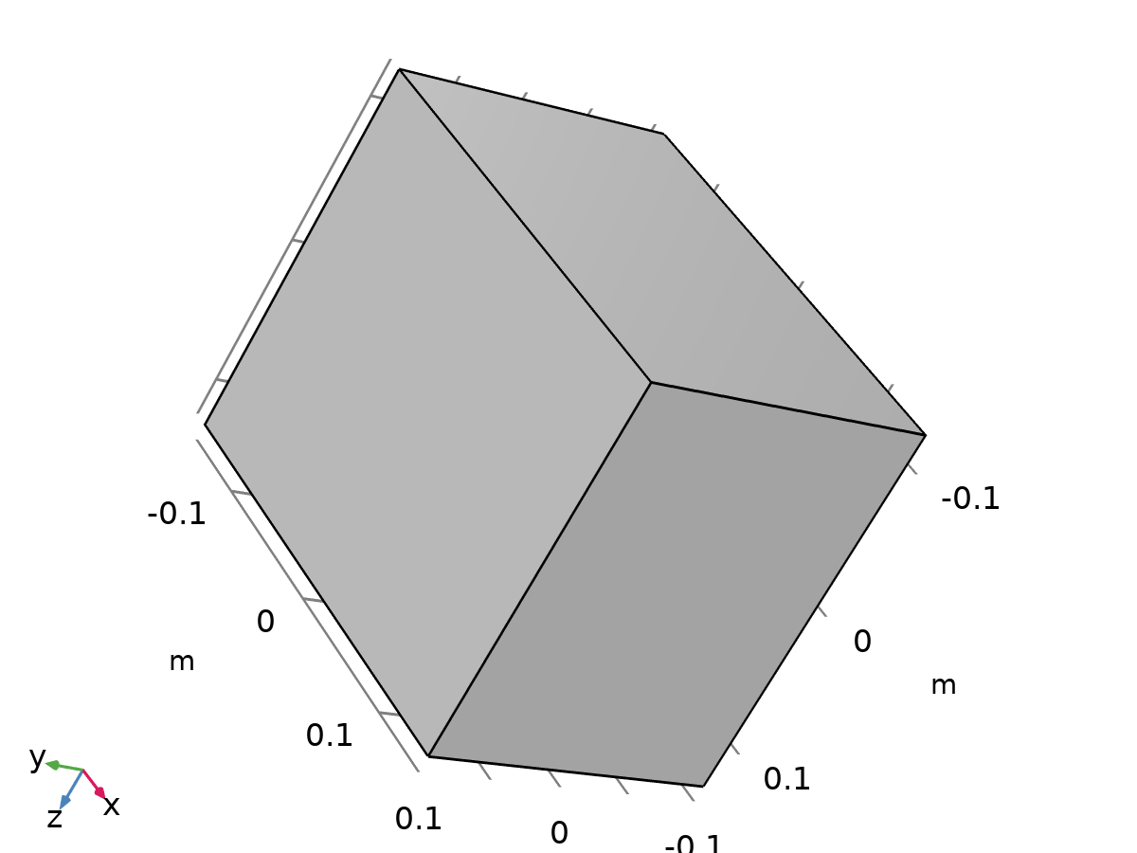

Geometry 1

Units

|  |  |
| --- | --- |
| Length unit | m |
| Angular unit | deg |

Geometry statistics

| **Description** | **Value** |
| --- | --- |
| Space dimension | 3 |
| Number of domains | 2 |
| Number of boundaries | 12 |
| Number of edges | 24 |
| Number of vertices | 16 |

### battery (blk1)

Size and shape

| **Description** | **Value** |
| --- | --- |
| Width | 0.1 |
| Depth | 0.05 |
| Height | 0.15 |

Position

| **Description** | **Value** |
| --- | --- |
| Base | Center |
| Position | {0, 0, 0} |

Axis

| **Description** | **Value** |
| --- | --- |
| Axis type | z - axis |

### Block 2 (blk2)

Size and shape

| **Description** | **Value** |
| --- | --- |
| Width | 0.3 |
| Depth | 0.2 |
| Height | 0.25 |

Position

| **Description** | **Value** |
| --- | --- |
| Base | Center |
| Position | {0, 0, 0} |

Axis

| **Description** | **Value** |
| --- | --- |
| Axis type | z - axis |

### Form Union (fin)

Information

| **Description** | **Value** |
| --- | --- |
| Build message | Formed union of 2 solid objects. Union has 2 domains, 12 boundaries, 24 edges, and 16 vertices. |

## Materials

### battery mat

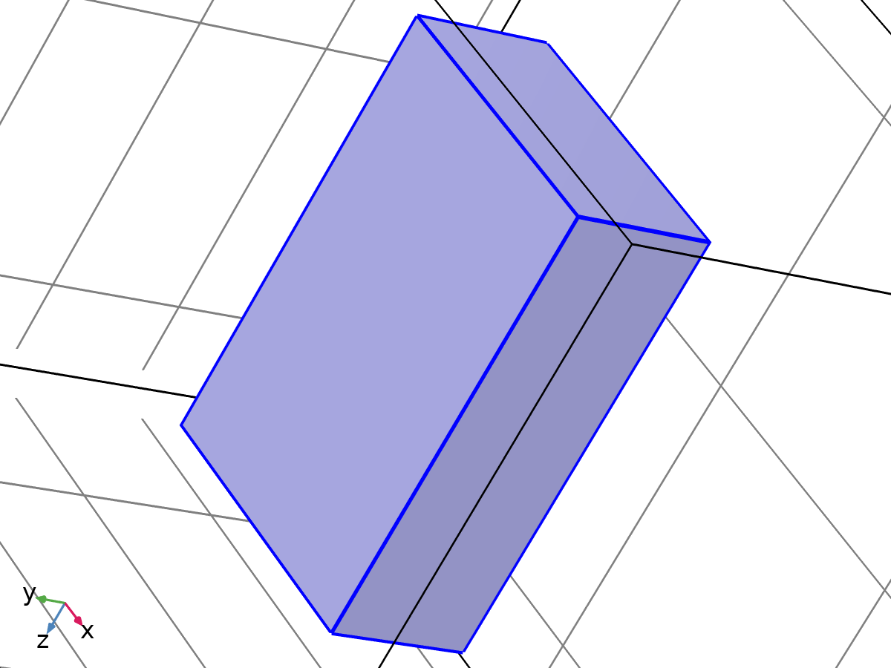

battery mat

Selection

|  |  |
| --- | --- |
| Geometric entity level | Domain |
| Selection | Geometry geom1: Dimension 3: Domain 2 |

Material parameters

| **Name** | **Value** | **Unit** | **Property group** |
| --- | --- | --- | --- |
| Density | 2500 | kg/m³ | Basic |
| Thermal conductivity | 1 | W/(m·K) | Basic |
| Heat capacity at constant pressure | 900 | J/(kg·K) | Basic |
| Dynamic viscosity | 0 | Pa·s | Basic |

Basic

| **Description** | **Value** | **Unit** |
| --- | --- | --- |
| Density | 2500 | kg/m³ |
| Thermal conductivity | 1 | W/(m·K) |
| Heat capacity at constant pressure | 900 | J/(kg·K) |
| Dynamic viscosity | 0 | Pa·s |

### Air

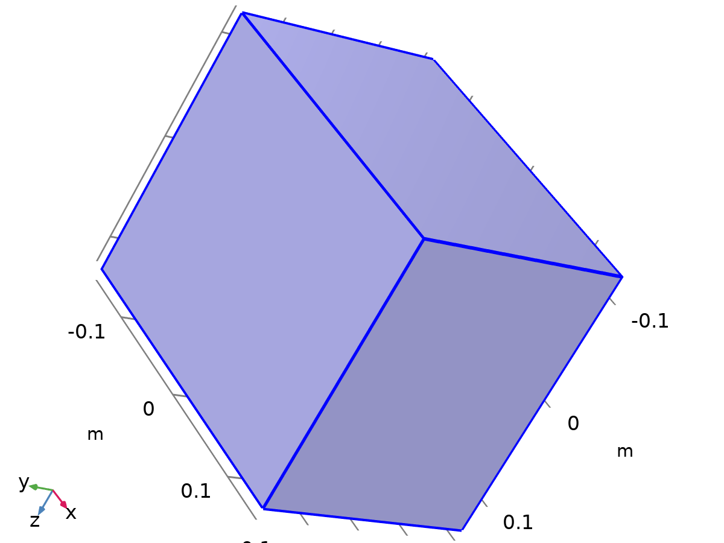

Air

Selection

|  |  |
| --- | --- |
| Geometric entity level | Domain |
| Selection | Geometry geom1: Dimension 3: Domain 1 |

Material parameters

| **Name** | **Value** | **Unit** | **Property group** |
| --- | --- | --- | --- |
| Dynamic viscosity | eta(T) | Pa·s | Basic |
| Density | rho(pA,T) | kg/m³ | Basic |
| Thermal conductivity | k(T) | W/(m·K) | Basic |
| Heat capacity at constant pressure | Cp(T) | J/(kg·K) | Ideal gas |

Basic

| **Description** | **Value** | **Unit** |
| --- | --- | --- |
| Dynamic viscosity | eta(T) | Pa·s |
| Heat capacity at constant pressure | Cp(T) | J/(kg·K) |
| Density | rho(pA, T) | kg/m³ |
| Thermal conductivity | k(T) | W/(m·K) |

Functions

| **Function name** | **Type** |
| --- | --- |
| eta | Piecewise |
| Cp | Piecewise |
| rho | Analytic |
| k | Piecewise |
| cs | Analytic |
| alpha_p | Analytic |
| muB | Analytic |

#### Piecewise

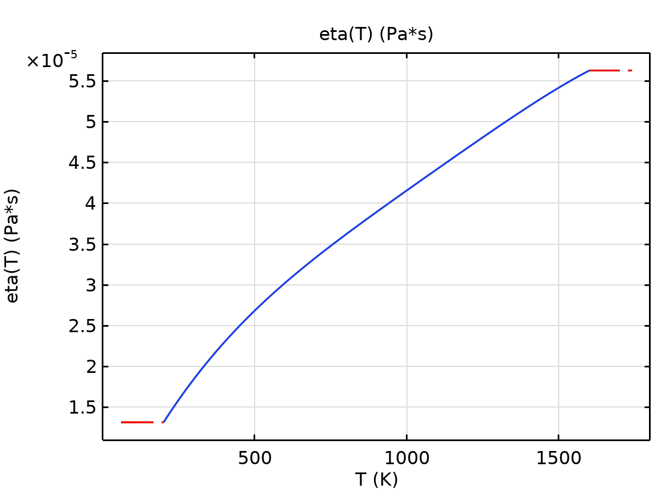

eta

#### Piecewise 2

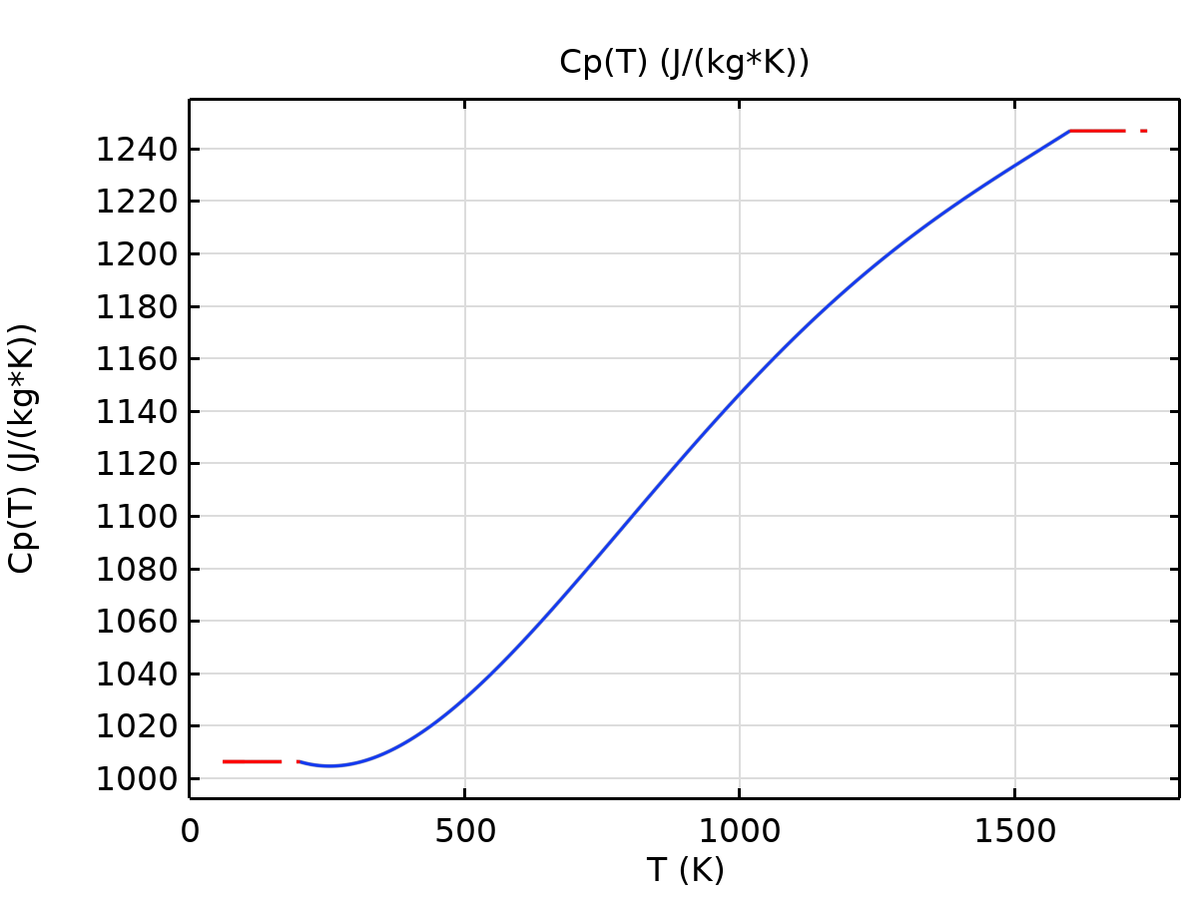

Cp

#### Analytic

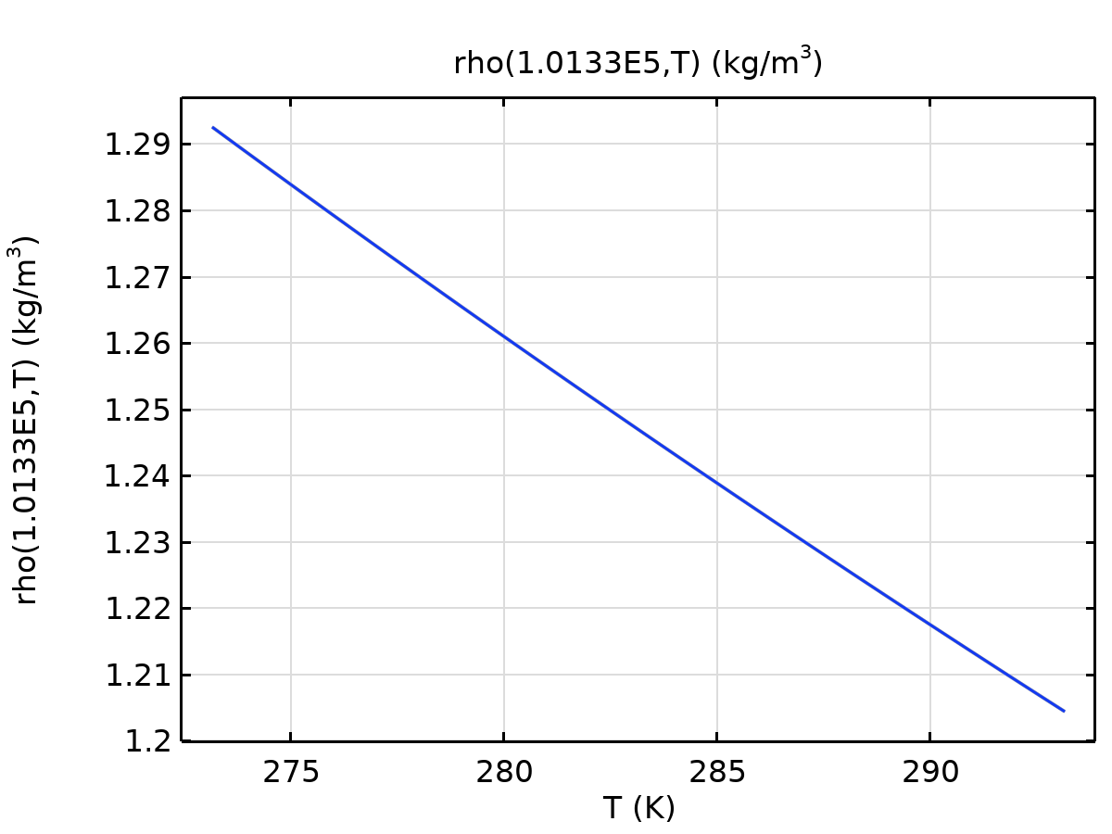

rho

#### Piecewise 3

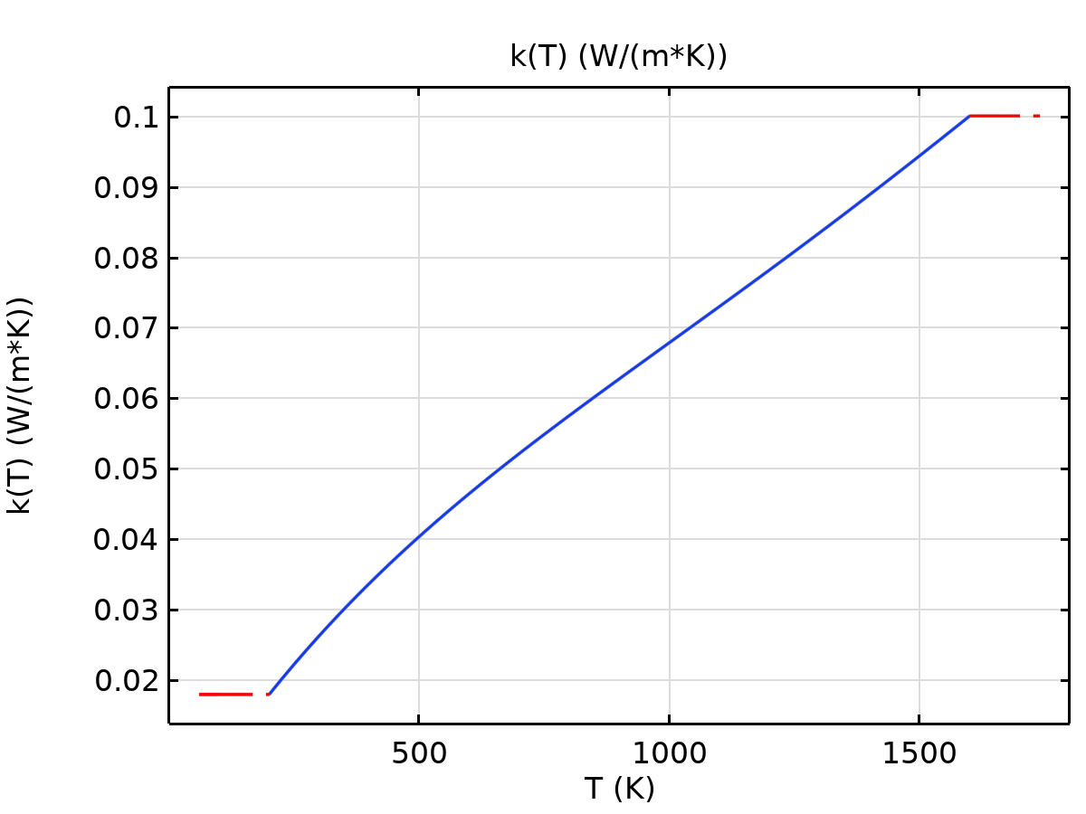

k

#### Analytic 2

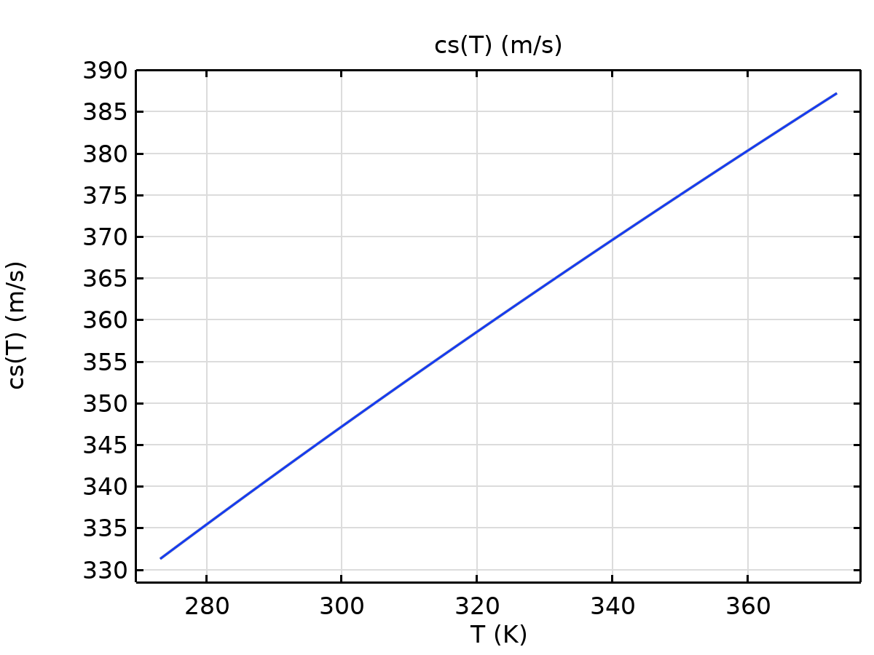

cs

#### Analytic 1

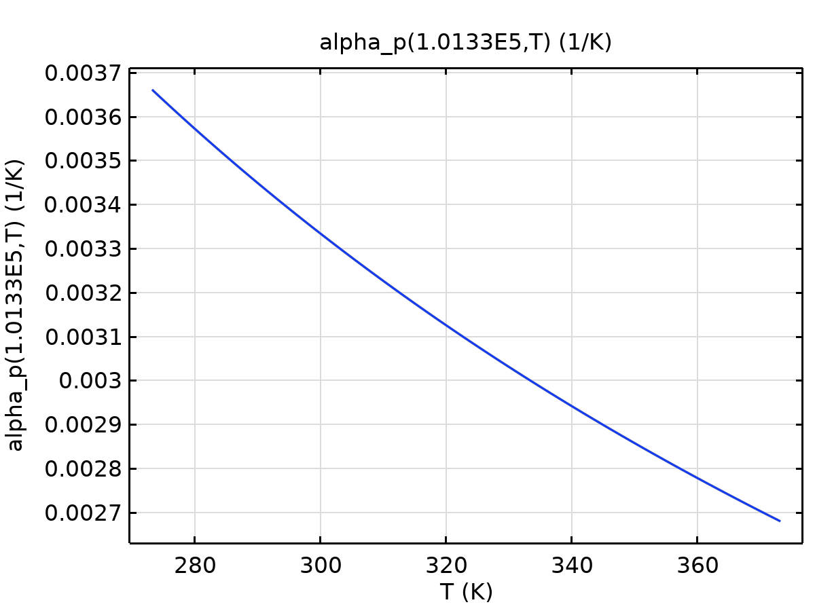

alpha_p

#### Analytic 2a

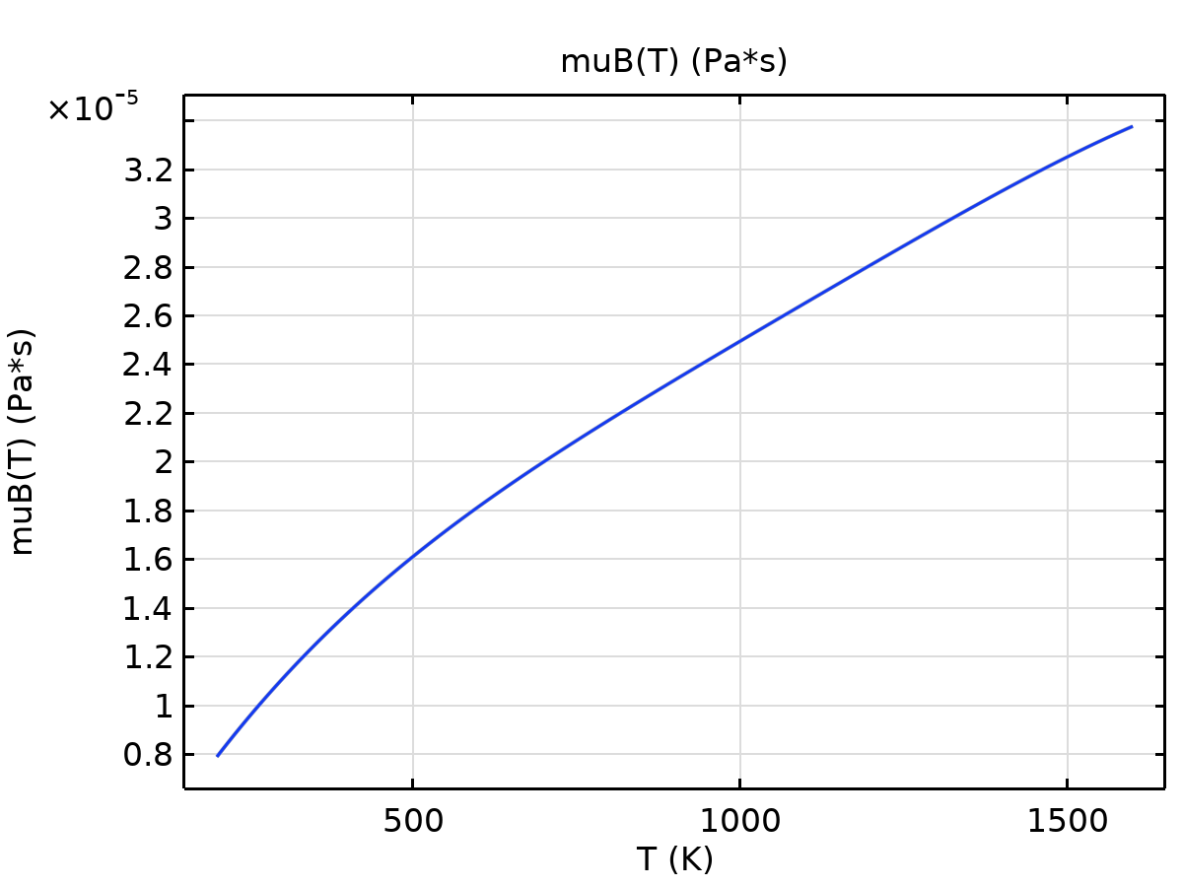

muB

Ideal gas

| **Description** | **Value** | **Unit** |
| --- | --- | --- |
| Heat capacity at constant pressure | Cp(T) | J/(kg·K) |

Functions

| **Function name** | **Type** |
| --- | --- |
| Cp | Piecewise |

#### Piecewise 2



Cp

## Laminar Flow

Used products

|  |
| --- |
| COMSOL Multiphysics |



Laminar Flow

Selection

|  |  |
| --- | --- |
| Geometric entity level | Domain |
| Selection | Geometry geom1: Dimension 3: All domains |

Equations

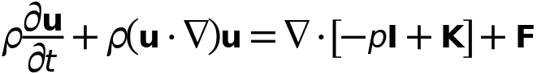



### Interface Settings

#### Discretization

Settings

| **Description** | **Value** |
| --- | --- |
| Discretization of fluids | P1 + P1 |

Settings

| **Description** | **Value** |
| --- | --- |
| Equation form | Study controlled |

#### Physical Model

Settings

| **Description** | **Value** | **Unit** |
| --- | --- | --- |
| Neglect inertial term (Stokes flow) | Off |  |
| Compressibility | Incompressible flow |  |
| Enable porous media domains | Off |  |
| Include gravity | Off |  |
| Reference temperature | User defined |  |
| Reference temperature | 293.15 | K |
| Reference pressure level | 1.0133E5 | Pa |

#### Turbulence

Settings

| **Description** | **Value** |
| --- | --- |
| Turbulence model type | None |

### Variables

| **Name** | **Expression** | **Unit** | **Description** | **Selection** | **Details** |
| --- | --- | --- | --- | --- | --- |
| spf.Tref | model.input.Tref | K | Reference temperature | Global | Meta |
| spf.dz | 1 | m | Thickness | Domains 1–2 |  |
| spf.pref | 1[atm] | Pa | Reference pressure level | Domains 1–2 |  |
| spf.pA | p+spf.pref | Pa | Absolute pressure | Domains 1–2 |  |
| spf.hasWF | 0 |  | Help variable | Boundaries 1–5, 12 |  |
| spf.hasWF_u | 0 |  | Help variable | Boundaries 6–11 |  |
| spf.hasWF_d | 0 |  | Help variable | Boundaries 6–11 |  |
| spf.dt_CFL | 1/max(spf.maxop(sqrt(emetric_spatial(u-d(x,TIME),v-d(y,TIME),w-d(z,TIME)))),eps) | s | Time step, CFL=1 | Global |  |
| spf.CFL_number | timestep/spf.dt_CFL | 1 | CFL number | Global |  |
| spf.Qvd_tot | spf.intop(spf.Qvd) | W | Total viscous dissipation | Global |  |
| spf.K_stressx | spf.K_stress_tensorxx*spf.nxmesh+spf.K_stress_tensorxy*spf.nymesh+spf.K_stress_tensorxz*spf.nzmesh | N/m² | Viscous stress, exterior boundaries, x-component | Boundaries 1–5, 12 |  |
| spf.K_stressy | spf.K_stress_tensoryx*spf.nxmesh+spf.K_stress_tensoryy*spf.nymesh+spf.K_stress_tensoryz*spf.nzmesh | N/m² | Viscous stress, exterior boundaries, y-component | Boundaries 1–5, 12 |  |
| spf.K_stressz | spf.K_stress_tensorzx*spf.nxmesh+spf.K_stress_tensorzy*spf.nymesh+spf.K_stress_tensorzz*spf.nzmesh | N/m² | Viscous stress, exterior boundaries, z-component | Boundaries 1–5, 12 |  |
| spf.T_stressx | spf.T_stress_tensorxx*spf.nxmesh+spf.T_stress_tensorxy*spf.nymesh+spf.T_stress_tensorxz*spf.nzmesh | N/m² | Total traction, exterior boundaries, x-component | Boundaries 1–5, 12 |  |
| spf.T_stressy | spf.T_stress_tensoryx*spf.nxmesh+spf.T_stress_tensoryy*spf.nymesh+spf.T_stress_tensoryz*spf.nzmesh | N/m² | Total traction, exterior boundaries, y-component | Boundaries 1–5, 12 |  |
| spf.T_stressz | spf.T_stress_tensorzx*spf.nxmesh+spf.T_stress_tensorzy*spf.nymesh+spf.T_stress_tensorzz*spf.nzmesh | N/m² | Total traction, exterior boundaries, z-component | Boundaries 1–5, 12 |  |
| spf.K_stress_dx | down(spf.K_stress_tensorxx)*spf.nxmesh+down(spf.K_stress_tensorxy)*spf.nymesh+down(spf.K_stress_tensorxz)*spf.nzmesh | N/m² | Viscous stress, interior boundaries, downside, x-component | Boundaries 6–11 |  |
| spf.K_stress_dy | down(spf.K_stress_tensoryx)*spf.nxmesh+down(spf.K_stress_tensoryy)*spf.nymesh+down(spf.K_stress_tensoryz)*spf.nzmesh | N/m² | Viscous stress, interior boundaries, downside, y-component | Boundaries 6–11 |  |
| spf.K_stress_dz | down(spf.K_stress_tensorzx)*spf.nxmesh+down(spf.K_stress_tensorzy)*spf.nymesh+down(spf.K_stress_tensorzz)*spf.nzmesh | N/m² | Viscous stress, interior boundaries, downside, z-component | Boundaries 6–11 |  |
| spf.K_stress_dx | down(spf.K_stress_tensorxx)*spf.dnxmesh+down(spf.K_stress_tensorxy)*spf.dnymesh+down(spf.K_stress_tensorxz)*spf.dnzmesh | N/m² | Viscous stress, interior boundaries, downside, x-component | Boundaries 1–5, 12 |  |
| spf.K_stress_dy | down(spf.K_stress_tensoryx)*spf.dnxmesh+down(spf.K_stress_tensoryy)*spf.dnymesh+down(spf.K_stress_tensoryz)*spf.dnzmesh | N/m² | Viscous stress, interior boundaries, downside, y-component | Boundaries 1–5, 12 |  |
| spf.K_stress_dz | down(spf.K_stress_tensorzx)*spf.dnxmesh+down(spf.K_stress_tensorzy)*spf.dnymesh+down(spf.K_stress_tensorzz)*spf.dnzmesh | N/m² | Viscous stress, interior boundaries, downside, z-component | Boundaries 1–5, 12 |  |
| spf.K_stress_ux | -up(spf.K_stress_tensorxx)*spf.nxmesh-up(spf.K_stress_tensorxy)*spf.nymesh-up(spf.K_stress_tensorxz)*spf.nzmesh | N/m² | Viscous stress, interior boundaries, upside, x-component | Boundaries 6–11 |  |
| spf.K_stress_uy | -up(spf.K_stress_tensoryx)*spf.nxmesh-up(spf.K_stress_tensoryy)*spf.nymesh-up(spf.K_stress_tensoryz)*spf.nzmesh | N/m² | Viscous stress, interior boundaries, upside, y-component | Boundaries 6–11 |  |
| spf.K_stress_uz | -up(spf.K_stress_tensorzx)*spf.nxmesh-up(spf.K_stress_tensorzy)*spf.nymesh-up(spf.K_stress_tensorzz)*spf.nzmesh | N/m² | Viscous stress, interior boundaries, upside, z-component | Boundaries 6–11 |  |
| spf.T_stress_dx | down(spf.T_stress_tensorxx)*spf.nxmesh+down(spf.T_stress_tensorxy)*spf.nymesh+down(spf.T_stress_tensorxz)*spf.nzmesh | N/m² | Total traction, interior boundaries, downside, x-component | Boundaries 6–11 |  |
| spf.T_stress_dy | down(spf.T_stress_tensoryx)*spf.nxmesh+down(spf.T_stress_tensoryy)*spf.nymesh+down(spf.T_stress_tensoryz)*spf.nzmesh | N/m² | Total traction, interior boundaries, downside, y-component | Boundaries 6–11 |  |
| spf.T_stress_dz | down(spf.T_stress_tensorzx)*spf.nxmesh+down(spf.T_stress_tensorzy)*spf.nymesh+down(spf.T_stress_tensorzz)*spf.nzmesh | N/m² | Total traction, interior boundaries, downside, z-component | Boundaries 6–11 |  |
| spf.T_stress_dx | down(spf.T_stress_tensorxx)*spf.dnxmesh+down(spf.T_stress_tensorxy)*spf.dnymesh+down(spf.T_stress_tensorxz)*spf.dnzmesh | N/m² | Total traction, interior boundaries, downside, x-component | Boundaries 1–5, 12 |  |
| spf.T_stress_dy | down(spf.T_stress_tensoryx)*spf.dnxmesh+down(spf.T_stress_tensoryy)*spf.dnymesh+down(spf.T_stress_tensoryz)*spf.dnzmesh | N/m² | Total traction, interior boundaries, downside, y-component | Boundaries 1–5, 12 |  |
| spf.T_stress_dz | down(spf.T_stress_tensorzx)*spf.dnxmesh+down(spf.T_stress_tensorzy)*spf.dnymesh+down(spf.T_stress_tensorzz)*spf.dnzmesh | N/m² | Total traction, interior boundaries, downside, z-component | Boundaries 1–5, 12 |  |
| spf.T_stress_ux | -up(spf.T_stress_tensorxx)*spf.nxmesh-up(spf.T_stress_tensorxy)*spf.nymesh-up(spf.T_stress_tensorxz)*spf.nzmesh | N/m² | Total traction, interior boundaries, upside, x-component | Boundaries 6–11 |  |
| spf.T_stress_uy | -up(spf.T_stress_tensoryx)*spf.nxmesh-up(spf.T_stress_tensoryy)*spf.nymesh-up(spf.T_stress_tensoryz)*spf.nzmesh | N/m² | Total traction, interior boundaries, upside, y-component | Boundaries 6–11 |  |
| spf.T_stress_uz | -up(spf.T_stress_tensorzx)*spf.nxmesh-up(spf.T_stress_tensorzy)*spf.nymesh-up(spf.T_stress_tensorzz)*spf.nzmesh | N/m² | Total traction, interior boundaries, upside, z-component | Boundaries 6–11 |  |
| spf.T_tracx | spf.T_stressx | N/m² | Total applied traction, exterior boundaries, x-component | Boundaries 1–5, 12 |  |
| spf.T_tracy | spf.T_stressy | N/m² | Total applied traction, exterior boundaries, y-component | Boundaries 1–5, 12 |  |
| spf.T_tracz | spf.T_stressz | N/m² | Total applied traction, exterior boundaries, z-component | Boundaries 1–5, 12 |  |
| spf.T_trac_dx | spf.T_stress_dx | N/m² | Total applied traction, downside boundaries, x-component | Boundaries 6–11 |  |
| spf.T_trac_dy | spf.T_stress_dy | N/m² | Total applied traction, downside boundaries, y-component | Boundaries 6–11 |  |
| spf.T_trac_dz | spf.T_stress_dz | N/m² | Total applied traction, downside boundaries, z-component | Boundaries 6–11 |  |
| spf.T_trac_dx | spf.T_stress_dx | N/m² | Total applied traction, downside boundaries, x-component | Boundaries 1–5, 12 |  |
| spf.T_trac_dy | spf.T_stress_dy | N/m² | Total applied traction, downside boundaries, y-component | Boundaries 1–5, 12 |  |
| spf.T_trac_dz | spf.T_stress_dz | N/m² | Total applied traction, downside boundaries, z-component | Boundaries 1–5, 12 |  |
| spf.T_trac_ux | spf.T_stress_ux | N/m² | Total applied traction, upside boundaries, x-component | Boundaries 6–11 |  |
| spf.T_trac_uy | spf.T_stress_uy | N/m² | Total applied traction, upside boundaries, y-component | Boundaries 6–11 |  |
| spf.T_trac_uz | spf.T_stress_uz | N/m² | Total applied traction, upside boundaries, z-component | Boundaries 6–11 |  |
| spf.usePseudoTimeStepping | isrunningpseudotimestepping | 1 | Help variable | Global |  |
| spf.localCFLvalue | 1.3^min(niterCMP,9)+if(niterCMP>=25,9*1.3^min(-25+niterCMP,9),0)+if(niterCMP>=45,90*1.3^min(-45+niterCMP,9),0) |  | Local CFL number | Domains 1–2 |  |
| spf.locCFL | max(CFLCMP,sqrt(eps)) | 1 | Local CFL number | Global |  |
| spf.geometryLengthScale | 0.05000000000000001 | m | Geometry length scale | Domains 1–2 |  |
| spf.time_step_inv | max(sqrt(emetric_spatial(u,v,w)*2^gmg_level^2),spf.nu/spf.geometryLengthScale^2) | Hz | Inverse time step | Domains 1–2 |  |
| spf.tsti | nojac(spf.time_step_inv/spf.locCFL) | 1/s | Help variable | Domains 1–2 |  |
| spf.nx | nx | 1 | Normal vector, x-component | Boundaries 6–11 |  |
| spf.ny | ny | 1 | Normal vector, y-component | Boundaries 6–11 |  |
| spf.nz | nz | 1 | Normal vector, z-component | Boundaries 6–11 |  |
| spf.nx | dnx | 1 | Normal vector, x-component | Boundaries 1–5, 12 |  |
| spf.ny | dny | 1 | Normal vector, y-component | Boundaries 1–5, 12 |  |
| spf.nz | dnz | 1 | Normal vector, z-component | Boundaries 1–5, 12 |  |
| spf.nxmesh | nxmesh | 1 | Normal vector, x-component | Boundaries 6–11 |  |
| spf.nymesh | nymesh | 1 | Normal vector, y-component | Boundaries 6–11 |  |
| spf.nzmesh | nzmesh | 1 | Normal vector, z-component | Boundaries 6–11 |  |
| spf.nxmesh | dnxmesh | 1 | Normal vector, x-component | Boundaries 1–5, 12 |  |
| spf.nymesh | dnymesh | 1 | Normal vector, y-component | Boundaries 1–5, 12 |  |
| spf.nzmesh | dnzmesh | 1 | Normal vector, z-component | Boundaries 1–5, 12 |  |

### Fluid Properties 1



Fluid Properties 1

Selection

|  |  |
| --- | --- |
| Geometric entity level | Domain |
| Selection | Geometry geom1: Dimension 3: All domains |

Equations

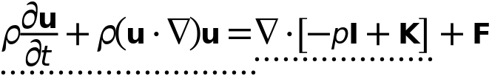



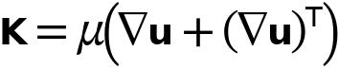

#### Fluid Properties

Settings

| **Description** | **Value** |
| --- | --- |
| Density | From material |
| Constitutive relation | Specify dynamic viscosity |
| Dynamic viscosity | From material |

#### Model Input

Settings

| **Description** | **Value** |
| --- | --- |
| Temperature | Common model input |

Properties from material

| **Property** | **Material** | **Property group** |
| --- | --- | --- |
| Density | battery mat | Basic |
| Dynamic viscosity | battery mat | Basic |
| Density | Air | Basic |
| Dynamic viscosity | Air | Basic |

#### Variables

| **Name** | **Expression** | **Unit** | **Description** | **Selection** | **Details** |
| --- | --- | --- | --- | --- | --- |
| spf.mu | material.mu | Pa·s | Dynamic viscosity | Domains 1–2 | Meta |
| spf.rho | subst(material.rho,spf.fp1.minput_temperature,spf.Trho,spf.fp1.minput_pressure,spf.prho) | kg/m³ | Density | Domains 1–2 | Meta |
| spf.Trho | spf.Tref | K | Temperature for density evaluation | Domains 1–2 |  |
| spf.prho | spf.pref | Pa | Pressure for the evaluation of density | Domains 1–2 |  |
| spf.rhoref | subst(material.rho,spf.fp1.minput_temperature,spf.Tref,spf.fp1.minput_pressure,spf.pref) | kg/m³ | Reference density | Domains 1–2 | Meta |
| spf.mumat | material.mu | Pa·s | Dynamic viscosity | Domains 1–2 | Meta |
| spf.srijxx | ux | 1/s | Strain rate tensor, xx-component | Domains 1–2 |  |
| spf.srijyx | 0.5*(vx+uy) | 1/s | Strain rate tensor, yx-component | Domains 1–2 |  |
| spf.srijzx | 0.5*(wx+uz) | 1/s | Strain rate tensor, zx-component | Domains 1–2 |  |
| spf.srijxy | 0.5*(uy+vx) | 1/s | Strain rate tensor, xy-component | Domains 1–2 |  |
| spf.srijyy | vy | 1/s | Strain rate tensor, yy-component | Domains 1–2 |  |
| spf.srijzy | 0.5*(wy+vz) | 1/s | Strain rate tensor, zy-component | Domains 1–2 |  |
| spf.srijxz | 0.5*(uz+wx) | 1/s | Strain rate tensor, xz-component | Domains 1–2 |  |
| spf.srijyz | 0.5*(vz+wy) | 1/s | Strain rate tensor, yz-component | Domains 1–2 |  |
| spf.srijzz | wz | 1/s | Strain rate tensor, zz-component | Domains 1–2 |  |
| spf.rrijxx | 0 | 1/s | Rotation rate tensor, xx-component | Domains 1–2 |  |
| spf.rrijyx | 0.5*(vx-uy) | 1/s | Rotation rate tensor, yx-component | Domains 1–2 |  |
| spf.rrijzx | 0.5*(wx-uz) | 1/s | Rotation rate tensor, zx-component | Domains 1–2 |  |
| spf.rrijxy | 0.5*(uy-vx) | 1/s | Rotation rate tensor, xy-component | Domains 1–2 |  |
| spf.rrijyy | 0 | 1/s | Rotation rate tensor, yy-component | Domains 1–2 |  |
| spf.rrijzy | 0.5*(wy-vz) | 1/s | Rotation rate tensor, zy-component | Domains 1–2 |  |
| spf.rrijxz | 0.5*(uz-wx) | 1/s | Rotation rate tensor, xz-component | Domains 1–2 |  |
| spf.rrijyz | 0.5*(vz-wy) | 1/s | Rotation rate tensor, yz-component | Domains 1–2 |  |
| spf.rrijzz | 0 | 1/s | Rotation rate tensor, zz-component | Domains 1–2 |  |
| spf.sr | sqrt(2*spf.srijxx^2+2*spf.srijxy^2+2*spf.srijxz^2+2*spf.srijyx^2+2*spf.srijyy^2+2*spf.srijyz^2+2*spf.srijzx^2+2*spf.srijzy^2+2*spf.srijzz^2+eps) | 1/s | Shear rate | Domains 1–2 |  |
| spf.rr | sqrt(2*spf.rrijxx^2+2*spf.rrijxy^2+2*spf.rrijxz^2+2*spf.rrijyx^2+2*spf.rrijyy^2+2*spf.rrijyz^2+2*spf.rrijzx^2+2*spf.rrijzy^2+2*spf.rrijzz^2+eps) | 1/s | Rotation rate | Domains 1–2 |  |
| spf.divu | ux+vy+wz | 1/s | Divergence of velocity field | Domains 1–2 |  |
| spf.Fx | 0 | N/m³ | Volume force, x-component | Domains 1–2 | + operation |
| spf.Fy | 0 | N/m³ | Volume force, y-component | Domains 1–2 | + operation |
| spf.Fz | 0 | N/m³ | Volume force, z-component | Domains 1–2 | + operation |
| spf.U | sqrt(u^2+v^2+w^2) | m/s | Velocity magnitude | Domains 1–2 |  |
| spf.vorticityx | wy-vz | 1/s | Vorticity field, x-component | Domains 1–2 |  |
| spf.vorticityy | -wx+uz | 1/s | Vorticity field, y-component | Domains 1–2 |  |
| spf.vorticityz | vx-uy | 1/s | Vorticity field, z-component | Domains 1–2 |  |
| spf.vort_magn | sqrt(spf.vorticityx^2+spf.vorticityy^2+spf.vorticityz^2) | 1/s | Vorticity magnitude | Domains 1–2 |  |
| spf.cellRe | 0.25*spf.rho*sqrt(emetric_spatial(u-d(x,TIME),v-d(y,TIME),w-d(z,TIME))/emetric2_spatial)/spf.mu | 1 | Cell Reynolds number | Domains 1–2 |  |
| spf.nu | spf.mu/spf.rho | m²/s | Kinematic viscosity | Domains 1–2 |  |
| spf.betaT | 0 | 1/Pa | Isothermal compressibility coefficient | Domains 1–2 |  |
| spf.Qm | 0 | kg/(m³·s) | Source term | Domains 1–2 | + operation |
| spf.Fgtotx | 0 | N/m³ | Gravity force, x-component | Domains 1–2 | + operation |
| spf.Fgtoty | 0 | N/m³ | Gravity force, y-component | Domains 1–2 | + operation |
| spf.Fgtotz | 0 | N/m³ | Gravity force, z-component | Domains 1–2 | + operation |
| spf.Qm_aco | 0 | kg/(m³·s) | Acoustic mass source | Domains 1–2 |  |
| spf.F_acox | 0 | N/m³ | Acoustic volume force, x-component | Domains 1–2 |  |
| spf.F_acoy | 0 | N/m³ | Acoustic volume force, y-component | Domains 1–2 |  |
| spf.F_acoz | 0 | N/m³ | Acoustic volume force, z-component | Domains 1–2 |  |
| spf.gamma_sr | sqrt(2*spf.srijxx^2+2*spf.srijxy^2+2*spf.srijxz^2+2*spf.srijyx^2+2*spf.srijyy^2+2*spf.srijyz^2+2*spf.srijzx^2+2*spf.srijzy^2+2*spf.srijzz^2+eps) | 1/s | Shear rate | Domains 1–2 |  |
| spf.mu_eff | spf.mu+spf.muT | Pa·s | Effective dynamic viscosity | Domains 1–2 |  |
| spf.muT | 0 | Pa·s | Turbulent dynamic viscosity | Domains 1–2 | + operation |
| spf.T_stress_tensorxx | spf.K_stress_tensorxx-p | N/m² | Total stress tensor, xx-component | Domains 1–2 | + operation |
| spf.T_stress_tensoryx | spf.K_stress_tensoryx | N/m² | Total stress tensor, yx-component | Domains 1–2 | + operation |
| spf.T_stress_tensorzx | spf.K_stress_tensorzx | N/m² | Total stress tensor, zx-component | Domains 1–2 | + operation |
| spf.T_stress_tensorxy | spf.K_stress_tensorxy | N/m² | Total stress tensor, xy-component | Domains 1–2 | + operation |
| spf.T_stress_tensoryy | spf.K_stress_tensoryy-p | N/m² | Total stress tensor, yy-component | Domains 1–2 | + operation |
| spf.T_stress_tensorzy | spf.K_stress_tensorzy | N/m² | Total stress tensor, zy-component | Domains 1–2 | + operation |
| spf.T_stress_tensorxz | spf.K_stress_tensorxz | N/m² | Total stress tensor, xz-component | Domains 1–2 | + operation |
| spf.T_stress_tensoryz | spf.K_stress_tensoryz | N/m² | Total stress tensor, yz-component | Domains 1–2 | + operation |
| spf.T_stress_tensorzz | spf.K_stress_tensorzz-p | N/m² | Total stress tensor, zz-component | Domains 1–2 | + operation |
| spf.K_stress_tensorxx | 2*spf.mu_eff*ux | N/m² | Viscous stress tensor, xx-component | Domains 1–2 | + operation |
| spf.K_stress_tensoryx | spf.mu_eff*(vx+uy) | N/m² | Viscous stress tensor, yx-component | Domains 1–2 | + operation |
| spf.K_stress_tensorzx | spf.mu_eff*(wx+uz) | N/m² | Viscous stress tensor, zx-component | Domains 1–2 | + operation |
| spf.K_stress_tensorxy | spf.mu_eff*(uy+vx) | N/m² | Viscous stress tensor, xy-component | Domains 1–2 | + operation |
| spf.K_stress_tensoryy | 2*spf.mu_eff*vy | N/m² | Viscous stress tensor, yy-component | Domains 1–2 | + operation |
| spf.K_stress_tensorzy | spf.mu_eff*(wy+vz) | N/m² | Viscous stress tensor, zy-component | Domains 1–2 | + operation |
| spf.K_stress_tensorxz | spf.mu_eff*(uz+wx) | N/m² | Viscous stress tensor, xz-component | Domains 1–2 | + operation |
| spf.K_stress_tensoryz | spf.mu_eff*(vz+wy) | N/m² | Viscous stress tensor, yz-component | Domains 1–2 | + operation |
| spf.K_stress_tensorzz | 2*spf.mu_eff*wz | N/m² | Viscous stress tensor, zz-component | Domains 1–2 | + operation |
| spf.K_stress_tensor_testxx | 2*spf.mu_eff*test(ux) | N/m² | Viscous stress tensor test, xx-component | Domains 1–2 | + operation |
| spf.K_stress_tensor_testyx | spf.mu_eff*(test(vx)+test(uy)) | N/m² | Viscous stress tensor test, yx-component | Domains 1–2 | + operation |
| spf.K_stress_tensor_testzx | spf.mu_eff*(test(wx)+test(uz)) | N/m² | Viscous stress tensor test, zx-component | Domains 1–2 | + operation |
| spf.K_stress_tensor_testxy | spf.mu_eff*(test(uy)+test(vx)) | N/m² | Viscous stress tensor test, xy-component | Domains 1–2 | + operation |
| spf.K_stress_tensor_testyy | 2*spf.mu_eff*test(vy) | N/m² | Viscous stress tensor test, yy-component | Domains 1–2 | + operation |
| spf.K_stress_tensor_testzy | spf.mu_eff*(test(wy)+test(vz)) | N/m² | Viscous stress tensor test, zy-component | Domains 1–2 | + operation |
| spf.K_stress_tensor_testxz | spf.mu_eff*(test(uz)+test(wx)) | N/m² | Viscous stress tensor test, xz-component | Domains 1–2 | + operation |
| spf.K_stress_tensor_testyz | spf.mu_eff*(test(vz)+test(wy)) | N/m² | Viscous stress tensor test, yz-component | Domains 1–2 | + operation |
| spf.K_stress_tensor_testzz | 2*spf.mu_eff*test(wz) | N/m² | Viscous stress tensor test, zz-component | Domains 1–2 | + operation |
| spf.upwind_helpx | u-d(x,TIME) | m/s | Upwind term, x-component | Domains 1–2 | + operation |
| spf.upwind_helpy | v-d(y,TIME) | m/s | Upwind term, y-component | Domains 1–2 | + operation |
| spf.upwind_helpz | w-d(z,TIME) | m/s | Upwind term, z-component | Domains 1–2 | + operation |
| spf.continuityEquation | spf.rho*spf.divu-spf.Qm | kg/(m³·s) | Continuity equation | Domains 1–2 |  |
| spf.contCoeff | spf.rho | kg/m³ | Help variable | Domains 1–2 |  |
| spf.Qvd | spf.K_stress_tensorxx*ux+spf.K_stress_tensorxy*uy+spf.K_stress_tensorxz*uz+spf.K_stress_tensoryx*vx+spf.K_stress_tensoryy*vy+spf.K_stress_tensoryz*vz+spf.K_stress_tensorzx*wx+spf.K_stress_tensorzy*wy+spf.K_stress_tensorzz*wz | W/m³ | Viscous dissipation | Domains 1–2 | + operation |
| spf.epsilon_p | 1 | 1 | Porosity | Domains 1–2 |  |
| spf.epsilon_p_pos | max(1,sqrt(eps)) | 1 | Positive porosity | Domains 1–2 |  |
| spf.Fst_tensorxx | 0 | N/m² | Surface tension force, xx-component | Domains 1–2 | + operation |
| spf.Fst_tensoryx | 0 | N/m² | Surface tension force, yx-component | Domains 1–2 | + operation |
| spf.Fst_tensorzx | 0 | N/m² | Surface tension force, zx-component | Domains 1–2 | + operation |
| spf.Fst_tensorxy | 0 | N/m² | Surface tension force, xy-component | Domains 1–2 | + operation |
| spf.Fst_tensoryy | 0 | N/m² | Surface tension force, yy-component | Domains 1–2 | + operation |
| spf.Fst_tensorzy | 0 | N/m² | Surface tension force, zy-component | Domains 1–2 | + operation |
| spf.Fst_tensorxz | 0 | N/m² | Surface tension force, xz-component | Domains 1–2 | + operation |
| spf.Fst_tensoryz | 0 | N/m² | Surface tension force, yz-component | Domains 1–2 | + operation |
| spf.Fst_tensorzz | 0 | N/m² | Surface tension force, zz-component | Domains 1–2 | + operation |
| spf.res_u | spf.rho*ut*spf.switch_NS+px+spf.rho*u*ux+spf.rho*v*uy+spf.rho*w*uz-(d(2*ux,x)+d(uy+vx,y)+d(uz+wx,z))*spf.mu-spf.Fx | N/m³ | Equation residual | Domains 1–2 |  |
| spf.res_v | spf.rho*vt*spf.switch_NS+spf.rho*u*vx+py+spf.rho*v*vy+spf.rho*w*vz-(d(vx+uy,x)+d(2*vy,y)+d(vz+wy,z))*spf.mu-spf.Fy | N/m³ | Equation residual | Domains 1–2 |  |
| spf.res_w | spf.rho*wt*spf.switch_NS+spf.rho*u*wx+spf.rho*v*wy+pz+spf.rho*w*wz-(d(wx+uz,x)+d(wy+vz,y)+d(2*wz,z))*spf.mu-spf.Fz | N/m³ | Equation residual | Domains 1–2 |  |
| spf.res_p | spf.rho*spf.divu-spf.Qm | kg/(m³·s) | Pressure equation residual | Domains 1–2 |  |

#### Shape functions

| **Name** | **Shape function** | **Unit** | **Description** | **Shape frame** | **Selection** |
| --- | --- | --- | --- | --- | --- |
| u | Lagrange (Linear) | m/s | Velocity field, x-component | Spatial | Domains 1–2 |
| v | Lagrange (Linear) | m/s | Velocity field, y-component | Spatial | Domains 1–2 |
| w | Lagrange (Linear) | m/s | Velocity field, z-component | Spatial | Domains 1–2 |
| u | Lagrange (Linear) | m/s | Velocity field, x-component | Spatial | Domains 1–2 |
| v | Lagrange (Linear) | m/s | Velocity field, y-component | Spatial | Domains 1–2 |
| w | Lagrange (Linear) | m/s | Velocity field, z-component | Spatial | Domains 1–2 |
| p | Lagrange (Linear) | Pa | Pressure | Spatial | Domains 1–2 |

#### Weak Expressions

| **Weak expression** | **Integration order** | **Integration frame** | **Selection** |
| --- | --- | --- | --- |
| spf.rho*(-ut*test(u)-vt*test(v)-wt*test(w)) | 2 | Spatial | Domains 1–2 |
| (p-spf.K_stress_tensorxx)*test(ux)-spf.K_stress_tensorxy*test(uy)-spf.K_stress_tensorxz*test(uz)-spf.K_stress_tensoryx*test(vx)+(p-spf.K_stress_tensoryy)*test(vy)-spf.K_stress_tensoryz*test(vz)-spf.K_stress_tensorzx*test(wx)-spf.K_stress_tensorzy*test(wy)+(p-spf.K_stress_tensorzz)*test(wz) | 2 | Spatial | Domains 1–2 |
| spf.Fx*test(u)+spf.Fy*test(v)+spf.Fz*test(w) | 2 | Spatial | Domains 1–2 |
| spf.rho*(-(d(u,x)*u+d(u,y)*v+d(u,z)*w)*test(u)-(d(v,x)*u+d(v,y)*v+d(v,z)*w)*test(v)-(d(w,x)*u+d(w,y)*v+d(w,z)*w)*test(w)) | 2 | Spatial | Domains 1–2 |
| -spf.continuityEquation*test(p) | 2 | Spatial | Domains 1–2 |
| spf.streamlinens | 2 | Spatial | Domains 1–2 |
| spf.crosswindns | 2 | Spatial | Domains 1–2 |

### Initial Values 1



Initial Values 1

Selection

|  |  |
| --- | --- |
| Geometric entity level | Domain |
| Selection | Geometry geom1: Dimension 3: All domains |

#### Initial Values

Settings

| **Description** | **Value** | **Unit** |
| --- | --- | --- |
| Velocity field, x-component | 0.2 | m/s |
| Velocity field, y-component | 0 | m/s |
| Velocity field, z-component | 0 | m/s |
| Pressure | 0 | Pa |

#### Coordinate System Selection

Settings

| **Description** | **Value** |
| --- | --- |
| Coordinate system | Global coordinate system |

#### Variables

| **Name** | **Expression** | **Unit** | **Description** | **Selection** |
| --- | --- | --- | --- | --- |
| spf.u_initx | 0.2 | m/s | Velocity field, x-component | Domains 1–2 |
| spf.u_inity | 0 | m/s | Velocity field, y-component | Domains 1–2 |
| spf.u_initz | 0 | m/s | Velocity field, z-component | Domains 1–2 |
| spf.p_init | 0 | Pa | Pressure | Domains 1–2 |

### Wall 1

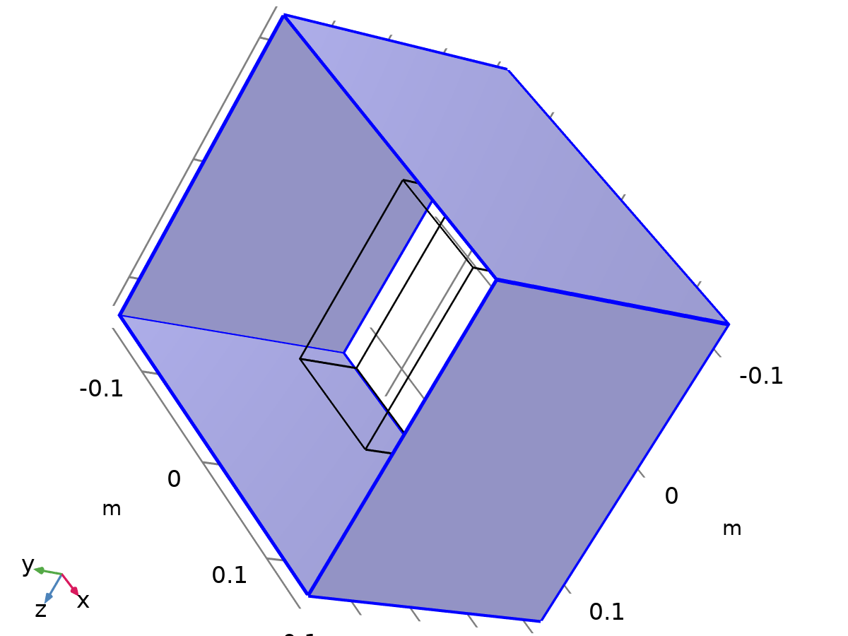

Wall 1

Selection

|  |  |
| --- | --- |
| Geometric entity level | Boundary |
| Selection | Geometry geom1: Dimension 2: All boundaries |

Equations



#### Boundary Condition

Settings

| **Description** | **Value** |
| --- | --- |
| Wall condition | No slip |

#### Wall Movement

Settings

| **Description** | **Value** |
| --- | --- |
| Translational velocity | Automatic from frame |
| Sliding wall | Off |

#### Variables

| **Name** | **Expression** | **Unit** | **Description** | **Selection** | **Details** |
| --- | --- | --- | --- | --- | --- |
| spf.ubndx | spf.utrx+spf.usx | m/s | Velocity at boundary, x-component | Boundaries 1, 3–4, 12 |  |
| spf.ubndy | spf.utry+spf.usy | m/s | Velocity at boundary, y-component | Boundaries 1, 3–4, 12 |  |
| spf.ubndz | spf.utrz+spf.usz | m/s | Velocity at boundary, z-component | Boundaries 1, 3–4, 12 |  |
| spf.usx | 0 | m/s | Velocity of sliding wall, x-component | Boundaries 1, 3–4, 12 |  |
| spf.usy | 0 | m/s | Velocity of sliding wall, y-component | Boundaries 1, 3–4, 12 |  |
| spf.usz | 0 | m/s | Velocity of sliding wall, z-component | Boundaries 1, 3–4, 12 |  |
| spf.utrx | 0 | m/s | Velocity of moving wall, x-component | Boundaries 1, 3–4, 12 |  |
| spf.utry | 0 | m/s | Velocity of moving wall, y-component | Boundaries 1, 3–4, 12 |  |
| spf.utrz | 0 | m/s | Velocity of moving wall, z-component | Boundaries 1, 3–4, 12 |  |
| spf.uLeakagex | 0 | m/s | Leakage velocity, x-component | Boundaries 1, 3–4, 12 | + operation |
| spf.uLeakagey | 0 | m/s | Leakage velocity, y-component | Boundaries 1, 3–4, 12 | + operation |
| spf.uLeakagez | 0 | m/s | Leakage velocity, z-component | Boundaries 1, 3–4, 12 | + operation |
| spf.noSlipWall | 1 | 1 | Help variable | Boundaries 1, 3–4, 12 |  |

#### Constraints

| **Constraint** | **Constraint force** | **Shape function** | **Selection** | **Details** |
| --- | --- | --- | --- | --- |
| -u+spf.ubndx+spf.uLeakagex | test(-u) | Lagrange (Linear) | Boundaries 1, 3–4, 12 | Elemental |
| -v+spf.ubndy+spf.uLeakagey | test(-v) | Lagrange (Linear) | Boundaries 1, 3–4, 12 | Elemental |
| -w+spf.ubndz+spf.uLeakagez | test(-w) | Lagrange (Linear) | Boundaries 1, 3–4, 12 | Elemental |

### Inlet 1

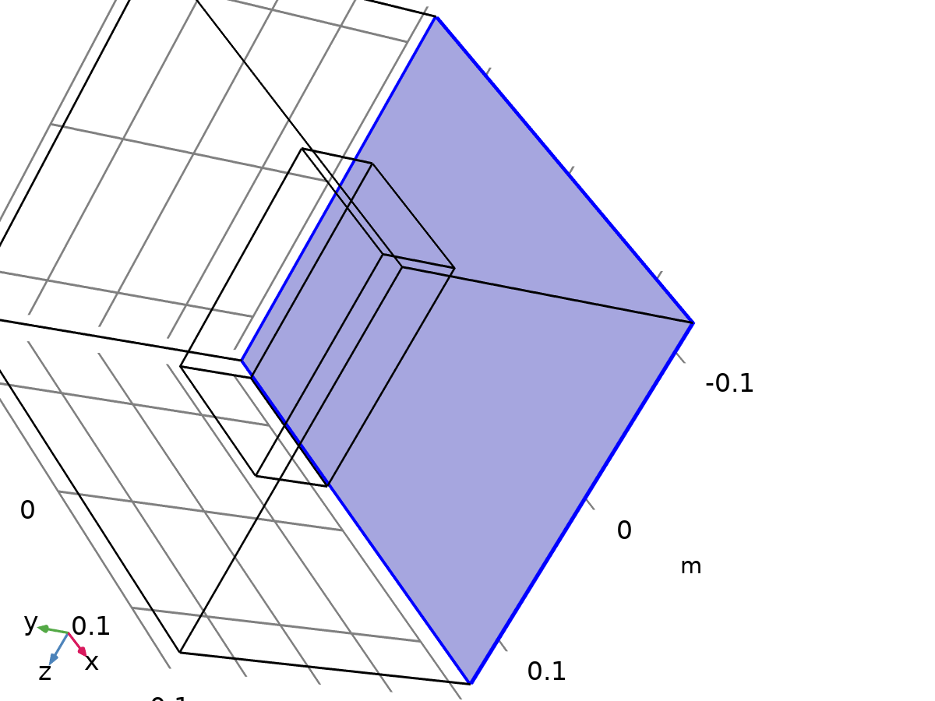

Inlet 1

Selection

|  |  |
| --- | --- |
| Geometric entity level | Boundary |
| Selection | Geometry geom1: Dimension 2: Boundary 2 |

Equations



#### Boundary Condition

Settings

| **Description** | **Value** |
| --- | --- |
| Boundary condition | Velocity |

#### Velocity

Settings

| **Description** | **Value** | **Unit** |
| --- | --- | --- |
| Velocity field componentwise | Normal inflow velocity |  |
| Normal inflow velocity | 0.2 | m/s |

#### Variables

| **Name** | **Expression** | **Unit** | **Description** | **Selection** |
| --- | --- | --- | --- | --- |
| spf.ubndx | -nojac(spf.nxmesh)*spf.U0in | m/s | Velocity at boundary, x-component | Boundary 2 |
| spf.ubndy | -nojac(spf.nymesh)*spf.U0in | m/s | Velocity at boundary, y-component | Boundary 2 |
| spf.ubndz | -nojac(spf.nzmesh)*spf.U0in | m/s | Velocity at boundary, z-component | Boundary 2 |
| spf.U0in | 0.2 | m/s | Normal inflow velocity | Boundary 2 |
| spf.inl1.dz | spf.dz | m | Channel thickness | Boundary 2 |
| spf.inl1.volumeFlowRate | spf.inl1.intop(u*spf.nxmesh+v*spf.nymesh+w*spf.nzmesh) | m³/s | Outward volume flow rate across feature selection | Global |
| spf.inl1.massFlowRate | spf.inl1.intop(spf.rho*(u*spf.nxmesh+v*spf.nymesh+w*spf.nzmesh)) | kg/s | Outward mass flow rate across feature selection | Global |
| spf.inl1.pAverage | spf.inl1.aveop(p) | Pa | Pressure average over feature selection | Global |

#### Constraints

| **Constraint** | **Constraint force** | **Shape function** | **Selection** | **Details** |
| --- | --- | --- | --- | --- |
| -u+spf.ubndx | test(-u) | Lagrange (Linear) | Boundary 2 | Elemental |
| -v+spf.ubndy | test(-v) | Lagrange (Linear) | Boundary 2 | Elemental |
| -w+spf.ubndz | test(-w) | Lagrange (Linear) | Boundary 2 | Elemental |

### Outlet 1

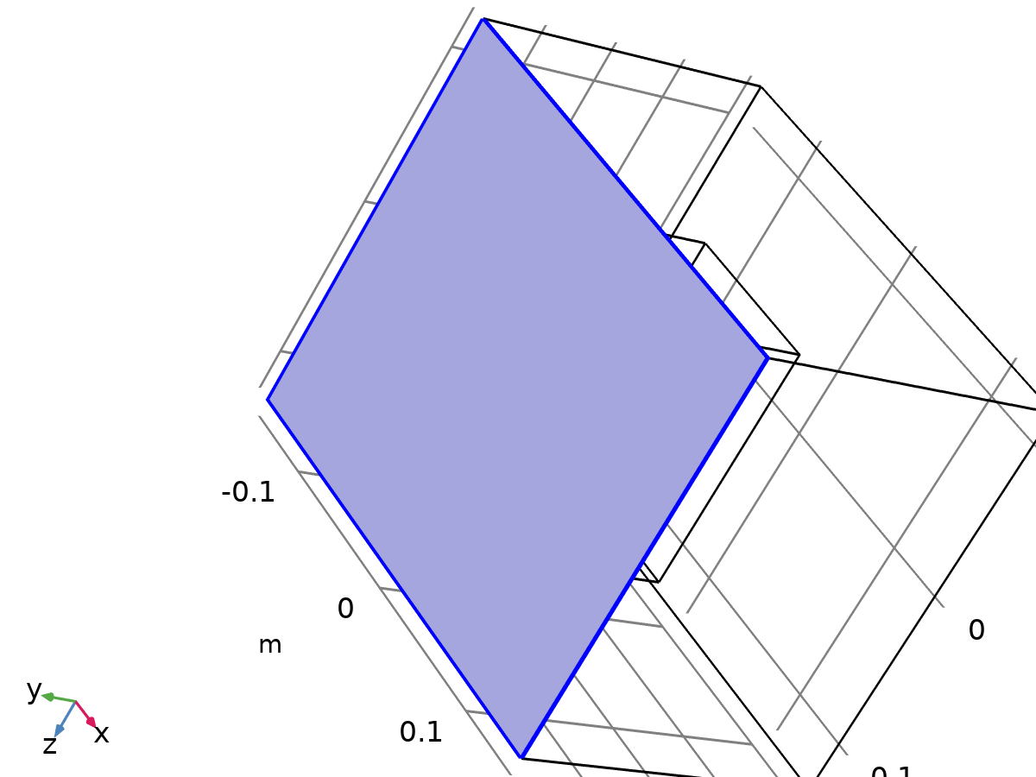

Outlet 1

Selection

|  |  |
| --- | --- |
| Geometric entity level | Boundary |
| Selection | Geometry geom1: Dimension 2: Boundary 5 |

Equations





#### Boundary Condition

Settings

| **Description** | **Value** |
| --- | --- |
| Boundary condition | Pressure |

#### Pressure Conditions

Settings

| **Description** | **Value** | **Unit** |
| --- | --- | --- |
| Pressure | Static |  |
| Pressure | 0 | Pa |
| Normal flow | Off |  |
| Suppress backflow | On |  |

#### Variables

| **Name** | **Expression** | **Unit** | **Description** | **Selection** |
| --- | --- | --- | --- | --- |
| spf.meshVol | meshvol_spatial | m² |  | Boundary 5 |
| spf.meshVolInt | down(meshvol_spatial) | m³ | Volume of interior mesh element | Boundary 5 |
| spf.rhoFace | down(spf.rho) | kg/m³ | Density face value | Boundary 5 |
| spf.umxTnFace | spf.upwind_helpx*spf.nxmesh+spf.upwind_helpy*spf.nymesh+spf.upwind_helpz*spf.nzmesh | m/s | Relative velocity on face | Boundary 5 |
| spf.p0 | 0 | Pa | Pressure | Boundary 5 |
| spf.out1.Uav | 0 | m/s | Average velocity | Global |
| spf.out1.p0avfdf | 0 | Pa | Average pressure | Global |
| spf.out1.dz | spf.dz | m | Channel thickness | Boundary 5 |
| spf.out1.Mflow | spf.out1.massFlowRate | kg/s | Mass flow | Global |
| spf.f0 | spf.p0+spf.uNormal*(spf.backflowPenaltyDiff-spf.backflowPenaltyConv)*(spf.uNormal<0) | N/m² | Normal stress | Boundary 5 |
| spf.uNormal | u*nojac(spf.nxmesh)+v*nojac(spf.nymesh)+w*nojac(spf.nzmesh) | m/s | Normal velocity | Boundary 5 |
| spf.out1.c_here | 144/spf.epsilon_p | 1 | Intermediate variable | Boundary 5 |
| spf.backflowPenaltyDiff | spf.out1.c_here*min((down(spf.mu)+spf.muT)*spf.meshVol/spf.meshVolInt,down(spf.rho)*abs(spf.uNormal)/down(spf.epsilon_p)) | Pa·s/m | Backflow penalty parameter, diffusive contribution | Boundary 5 |
| spf.backflowPenaltyConv | spf.rhoFace*spf.umxTnFace/spf.epsilon_p^2 | kg/(m²·s) | Backflow penalty parameter, convective contribution | Boundary 5 |
| spf.out1.upwind_ns | spf.backflowPenaltyConv*spf.uNormal | Pa | Upwind term | Boundary 5 |
| spf.out1.volumeFlowRate | spf.out1.intop(u*spf.nxmesh+v*spf.nymesh+w*spf.nzmesh) | m³/s | Outward volume flow rate across feature selection | Global |
| spf.out1.massFlowRate | spf.out1.intop(spf.rho*(u*spf.nxmesh+v*spf.nymesh+w*spf.nzmesh)) | kg/s | Outward mass flow rate across feature selection | Global |
| spf.out1.pAverage | spf.out1.aveop(p) | Pa | Pressure average over feature selection | Global |

#### Weak Expressions

| **Weak expression** | **Integration order** | **Integration frame** | **Selection** |
| --- | --- | --- | --- |
| -spf.f0*(test(u)*spf.nxmesh+test(v)*spf.nymesh+test(w)*spf.nzmesh) | 2 | Spatial | Boundary 5 |

## Heat Transfer in Solids

Used products

|  |
| --- |
| COMSOL Multiphysics |



Heat Transfer in Solids

Selection

|  |  |
| --- | --- |
| Geometric entity level | Domain |
| Selection | Geometry geom1: Dimension 3: Domains 1–2 |

Equations

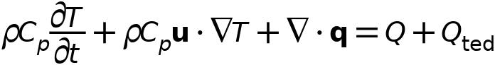



### Interface Settings

#### Discretization

Settings

| **Description** | **Value** |
| --- | --- |
| Temperature | Quadratic Lagrange |

Settings

| **Description** | **Value** |
| --- | --- |
| Equation form | Study controlled |

#### Physical Model

Settings

| **Description** | **Value** | **Unit** |
| --- | --- | --- |
| Reference temperature | User defined |  |
| Reference temperature | 293.15 | K |

### Variables

| **Name** | **Expression** | **Unit** | **Description** | **Selection** | **Details** |
| --- | --- | --- | --- | --- | --- |
| ht.Tref | model.input.Tref | K | Reference temperature | Global | Meta |
| ht.C_effExt | 0 | J/(m³·K) | Effective volumetric heat capacity | Domains 1–2 | + operation |
| ht.EMatExt | 0 | Pa | Young's modulus | Domains 1–2 | + operation |
| ht.Tvar | T | K | Temperature | Domains 1–2 |  |
| ht.Tvar | T | K | Temperature | Boundaries 1–12 |  |
| ht.Tvar | T | K | Temperature | Edges 1–24 |  |
| ht.Tvar | T | K | Temperature | Points 1–16 |  |
| ht.nknExt | 0 | W/(m·K) | Help variable | Domains 1–2 | + operation |
| ht.TextFace | 0 | K | External temperature | Domains 1–2 | + operation |
| ht.nuMatExt | 0 | 1 | Poisson's ratio | Domains 1–2 | + operation |
| ht.d | 1 | 1 | Thickness | Domains 1–2 |  |
| ht.chiT | 0 | 1/Pa | Isothermal compressibility coefficient | Domains 1–2 |  |
| ht.HRef | 0 | J/kg | Reference enthalpy | Domains 1–2 |  |
| ht.alphap | 0 | 1/K | Isobaric compressibility coefficient | Domains 1–2 |  |
| ht.DeltaH | ht.DeltaH_add | J/kg | Sensible enthalpy | Domains 1–2 |  |
| ht.DeltaH_cst | ht.DeltaH_add_cst | J/kg | Sensible enthalpy, constant material properties | Domains 1–2 |  |
| ht.DeltaH_add | 0 | J/kg | Sensible enthalpy | Domains 1–2 | + operation |
| ht.DeltaH_add_cst | 0 | J/kg | Sensible enthalpy, constant material properties | Domains 1–2 | + operation |
| ht.H | 0 | J/kg | Enthalpy | Domains 1–2 | + operation |
| ht.H_cst | 0 | J/kg | Enthalpy, constant material properties | Domains 1–2 | + operation |
| ht.H0 | ht.H+ht.Ek | J/kg | Total enthalpy | Domains 1–2 |  |
| ht.H0_cst | ht.H_cst+ht.Ek | J/kg | Total enthalpy, constant material properties | Domains 1–2 |  |
| ht.Ei | 0 | J/kg | Internal energy | Domains 1–2 | + operation |
| ht.Ei_cst | 0 | J/kg | Internal energy, constant material properties | Domains 1–2 | + operation |
| ht.Ei0 | ht.Ei+ht.Ek | J/kg | Total internal energy | Domains 1–2 |  |
| ht.Ei0_cst | ht.Ei_cst+ht.Ek | J/kg | Total internal energy, constant material properties | Domains 1–2 |  |
| ht.Ek | 0 | J/kg | Kinetic energy | Domains 1–2 | + operation |
| ht.dfluxx | 0 | W/m² | Conductive heat flux, x-component | Domains 1–2 | + operation |
| ht.dfluxy | 0 | W/m² | Conductive heat flux, y-component | Domains 1–2 | + operation |
| ht.dfluxz | 0 | W/m² | Conductive heat flux, z-component | Domains 1–2 | + operation |
| ht.dfluxx | mean(ht.dfluxx) | W/m² | Conductive heat flux, x-component | Boundaries 1–12 | + operation |
| ht.dfluxy | mean(ht.dfluxy) | W/m² | Conductive heat flux, y-component | Boundaries 1–12 | + operation |
| ht.dfluxz | mean(ht.dfluxz) | W/m² | Conductive heat flux, z-component | Boundaries 1–12 | + operation |
| ht.dfluxtestx | 0 | W/m² | Conductive heat flux, x-component | Domains 1–2 | + operation |
| ht.dfluxtesty | 0 | W/m² | Conductive heat flux, y-component | Domains 1–2 | + operation |
| ht.dfluxtestz | 0 | W/m² | Conductive heat flux, z-component | Domains 1–2 | + operation |
| ht.dfluxtestx | mean(ht.dfluxtestx) | W/m² | Conductive heat flux, x-component | Boundaries 1–12 | + operation |
| ht.dfluxtesty | mean(ht.dfluxtesty) | W/m² | Conductive heat flux, y-component | Boundaries 1–12 | + operation |
| ht.dfluxtestz | mean(ht.dfluxtestz) | W/m² | Conductive heat flux, z-component | Boundaries 1–12 | + operation |
| ht.dfluxMag | sqrt(ht.dfluxx^2+ht.dfluxy^2+ht.dfluxz^2) | W/m² | Conductive heat flux magnitude | Domains 1–2 |  |
| ht.cfluxx | 0 | W/m² | Convective heat flux, x-component | Domains 1–2 | + operation |
| ht.cfluxy | 0 | W/m² | Convective heat flux, y-component | Domains 1–2 | + operation |
| ht.cfluxz | 0 | W/m² | Convective heat flux, z-component | Domains 1–2 | + operation |
| ht.cfluxMag | sqrt(ht.cfluxx^2+ht.cfluxy^2+ht.cfluxz^2) | W/m² | Convective heat flux magnitude | Domains 1–2 |  |
| ht.tfluxx | ht.dfluxx+ht.cfluxx | W/m² | Total heat flux, x-component | Domains 1–2 |  |
| ht.tfluxy | ht.dfluxy+ht.cfluxy | W/m² | Total heat flux, y-component | Domains 1–2 |  |
| ht.tfluxz | ht.dfluxz+ht.cfluxz | W/m² | Total heat flux, z-component | Domains 1–2 |  |
| ht.tfluxMag | sqrt(ht.tfluxx^2+ht.tfluxy^2+ht.tfluxz^2) | W/m² | Total heat flux magnitude | Domains 1–2 |  |
| ht.tefluxx | 0 | W/m² | Total energy flux, x-component | Domains 1–2 | + operation |
| ht.tefluxy | 0 | W/m² | Total energy flux, y-component | Domains 1–2 | + operation |
| ht.tefluxz | 0 | W/m² | Total energy flux, z-component | Domains 1–2 | + operation |
| ht.teflux_cstx | 0 | W/m² | Total energy flux, constant material properties, x-component | Domains 1–2 | + operation |
| ht.teflux_csty | 0 | W/m² | Total energy flux, constant material properties, y-component | Domains 1–2 | + operation |
| ht.teflux_cstz | 0 | W/m² | Total energy flux, constant material properties, z-component | Domains 1–2 | + operation |
| ht.tefluxMag | sqrt(ht.tefluxx^2+ht.tefluxy^2+ht.tefluxz^2) | W/m² | Total energy flux magnitude | Domains 1–2 |  |
| ht.thfluxx | 0 | W/m² | Total enthalpy flux, x-component | Domains 1–2 | + operation |
| ht.thfluxy | 0 | W/m² | Total enthalpy flux, y-component | Domains 1–2 | + operation |
| ht.thfluxz | 0 | W/m² | Total enthalpy flux, z-component | Domains 1–2 | + operation |
| ht.thflux_cstx | 0 | W/m² | Total enthalpy flux, constant material properties, x-component | Domains 1–2 | + operation |
| ht.thflux_csty | 0 | W/m² | Total enthalpy flux, constant material properties, y-component | Domains 1–2 | + operation |
| ht.thflux_cstz | 0 | W/m² | Total enthalpy flux, constant material properties, z-component | Domains 1–2 | + operation |
| ht.thfluxMag | sqrt(ht.thfluxx^2+ht.thfluxy^2+ht.thfluxz^2) | W/m² | Total enthalpy flux magnitude | Domains 1–2 |  |
| ht.dflux_ux | up(ht.dfluxx) | W/m² | Conductive heat flux, x-component | Boundaries 1–12 |  |
| ht.dflux_uy | up(ht.dfluxy) | W/m² | Conductive heat flux, y-component | Boundaries 1–12 |  |
| ht.dflux_uz | up(ht.dfluxz) | W/m² | Conductive heat flux, z-component | Boundaries 1–12 |  |
| ht.dflux_dx | down(ht.dfluxx) | W/m² | Conductive heat flux, x-component | Boundaries 1–12 |  |
| ht.dflux_dy | down(ht.dfluxy) | W/m² | Conductive heat flux, y-component | Boundaries 1–12 |  |
| ht.dflux_dz | down(ht.dfluxz) | W/m² | Conductive heat flux, z-component | Boundaries 1–12 |  |
| ht.dfluxtest_ux | up(ht.dfluxtestx) | W/m² | Conductive heat flux, x-component | Boundaries 1–12 |  |
| ht.dfluxtest_uy | up(ht.dfluxtesty) | W/m² | Conductive heat flux, y-component | Boundaries 1–12 |  |
| ht.dfluxtest_uz | up(ht.dfluxtestz) | W/m² | Conductive heat flux, z-component | Boundaries 1–12 |  |
| ht.dfluxtest_dx | down(ht.dfluxtestx) | W/m² | Conductive heat flux, x-component | Boundaries 1–12 |  |
| ht.dfluxtest_dy | down(ht.dfluxtesty) | W/m² | Conductive heat flux, y-component | Boundaries 1–12 |  |
| ht.dfluxtest_dz | down(ht.dfluxtestz) | W/m² | Conductive heat flux, z-component | Boundaries 1–12 |  |
| ht.rflux | 0 | W/m² | Radiative heat flux | Boundaries 1–12 | + operation |
| ht.ncflux | mean(ht.cfluxx)*ht.nxmesh+mean(ht.cfluxy)*ht.nymesh+mean(ht.cfluxz)*ht.nzmesh | W/m² | Normal convective heat flux | Boundaries 1–12 |  |
| ht.ncflux_u | up(ht.cfluxx)*ht.unxmesh+up(ht.cfluxy)*ht.unymesh+up(ht.cfluxz)*ht.unzmesh | W/m² | Internal normal convective heat flux, upside | Boundaries 1–12 |  |
| ht.ncflux_d | down(ht.cfluxx)*ht.dnxmesh+down(ht.cfluxy)*ht.dnymesh+down(ht.cfluxz)*ht.dnzmesh | W/m² | Internal normal convective heat flux, downside | Boundaries 1–12 |  |
| ht.ndflux | 0.5*(ht.ndflux_d-ht.ndflux_u) | W/m² | Normal conductive heat flux | Boundaries 1–12 | + operation |
| ht.ndflux_u | -ht.ndflux_d | W/m² | Internal normal conductive heat flux, upside | Boundaries 1–5, 12 | + operation |
| ht.ndflux_u | 0 | W/m² | Internal normal conductive heat flux, upside | Boundaries 6–11 | + operation |
| ht.ndflux_d | 0 | W/m² | Internal normal conductive heat flux, downside | Boundaries 1–12 | + operation |
| ht.ntflux | ht.ndflux+ht.ncflux | W/m² | Normal total heat flux | Boundaries 1–12 |  |
| ht.ntflux_cst | ht.ndflux+ht.ncflux | W/m² | Normal total heat flux, constant material properties | Boundaries 1–12 |  |
| ht.ntflux_u | ht.ndflux_u+ht.ncflux_u | W/m² | Internal normal total flux, upside | Boundaries 1–12 |  |
| ht.ntflux_cst_u | ht.ndflux_u+ht.ncflux_u | W/m² | Internal normal total heat flux, constant material properties, upside | Boundaries 1–12 |  |
| ht.ntflux_d | ht.ndflux_d+ht.ncflux_d | W/m² | Internal normal total flux, downside | Boundaries 1–12 |  |
| ht.ntflux_cst_d | ht.ndflux_d+ht.ncflux_d | W/m² | Internal normal total heat flux, constant material properties, downside | Boundaries 1–12 |  |
| ht.nteflux | mean(ht.tefluxx)*ht.nxmesh+mean(ht.tefluxy)*ht.nymesh+mean(ht.tefluxz)*ht.nzmesh-mean(ht.dfluxx)*ht.nxmesh-mean(ht.dfluxy)*ht.nymesh-mean(ht.dfluxz)*ht.nzmesh+ht.ndflux | W/m² | Normal total energy flux | Boundaries 1–12 |  |
| ht.nteflux_cst | mean(ht.teflux_cstx)*ht.nxmesh+mean(ht.teflux_csty)*ht.nymesh+mean(ht.teflux_cstz)*ht.nzmesh-mean(ht.dfluxx)*ht.nxmesh-mean(ht.dfluxy)*ht.nymesh-mean(ht.dfluxz)*ht.nzmesh+ht.ndflux | W/m² | Normal total energy flux, constant material properties | Boundaries 1–12 |  |
| ht.nteflux_u | up(ht.tefluxx)*ht.unxmesh+up(ht.tefluxy)*ht.unymesh+up(ht.tefluxz)*ht.unzmesh-up(ht.dfluxx)*ht.unxmesh-up(ht.dfluxy)*ht.unymesh-up(ht.dfluxz)*ht.unzmesh+ht.ndflux_u | W/m² | Internal normal total energy flux, upside | Boundaries 1–12 |  |
| ht.nteflux_cst_u | up(ht.teflux_cstx)*ht.unxmesh+up(ht.teflux_csty)*ht.unymesh+up(ht.teflux_cstz)*ht.unzmesh-up(ht.dfluxx)*ht.unxmesh-up(ht.dfluxy)*ht.unymesh-up(ht.dfluxz)*ht.unzmesh+ht.ndflux_u | W/m² | Internal normal total energy flux, constant material properties, upside | Boundaries 1–12 |  |
| ht.nteflux_d | down(ht.tefluxx)*ht.dnxmesh+down(ht.tefluxy)*ht.dnymesh+down(ht.tefluxz)*ht.dnzmesh-down(ht.dfluxx)*ht.dnxmesh-down(ht.dfluxy)*ht.dnymesh-down(ht.dfluxz)*ht.dnzmesh+ht.ndflux_d | W/m² | Internal normal total energy flux, downside | Boundaries 1–12 |  |
| ht.nteflux_cst_d | down(ht.teflux_cstx)*ht.dnxmesh+down(ht.teflux_csty)*ht.dnymesh+down(ht.teflux_cstz)*ht.dnzmesh-down(ht.dfluxx)*ht.dnxmesh-down(ht.dfluxy)*ht.dnymesh-down(ht.dfluxz)*ht.dnzmesh+ht.ndflux_d | W/m² | Internal normal total energy flux, constant material properties, downside | Boundaries 1–12 |  |
| ht.nthflux | mean(ht.thfluxx)*ht.nxmesh+mean(ht.thfluxy)*ht.nymesh+mean(ht.thfluxz)*ht.nzmesh | W/m² | Normal total enthalpy flux | Boundaries 1–12 |  |
| ht.nthflux_cst | mean(ht.thflux_cstx)*ht.nxmesh+mean(ht.thflux_csty)*ht.nymesh+mean(ht.thflux_cstz)*ht.nzmesh | W/m² | Normal total enthalpy flux, constant material properties | Boundaries 1–12 |  |
| ht.nthflux_u | up(ht.thfluxx)*ht.unxmesh+up(ht.thfluxy)*ht.unymesh+up(ht.thfluxz)*ht.unzmesh | W/m² | Internal normal total enthalpy flux, upside | Boundaries 1–12 |  |
| ht.nthflux_cst_u | up(ht.thflux_cstx)*ht.unxmesh+up(ht.thflux_csty)*ht.unymesh+up(ht.thflux_cstz)*ht.unzmesh | W/m² | Internal normal total enthalpy flux, constant material properties, upside | Boundaries 1–12 |  |
| ht.nthflux_d | down(ht.thfluxx)*ht.dnxmesh+down(ht.thfluxy)*ht.dnymesh+down(ht.thfluxz)*ht.dnzmesh | W/m² | Internal normal total enthalpy flux, downside | Boundaries 1–12 |  |
| ht.nthflux_cst_d | down(ht.thflux_cstx)*ht.dnxmesh+down(ht.thflux_csty)*ht.dnymesh+down(ht.thflux_cstz)*ht.dnzmesh | W/m² | Internal normal total enthalpy flux, constant material properties, downside | Boundaries 1–12 |  |
| ht.Qm | 0 | kg/(m³·s) | Mass source | Domains 1–2 |  |
| ht.Q | 0 | W/m³ | Heat source | Domains 1–2 | + operation |
| ht.Qoop | 0 | W/m³ | Out-of-plane heat source | Domains 1–2 | + operation |
| ht.Qtot | 0 | W/m³ | Total heat source | Domains 1–2 | + operation |
| ht.Qbtot | 0 | W/m² | Total boundary heat source | Boundaries 1–12 | + operation |
| ht.ntflux_contrib | 0 | W/m² | Boundary sources and fluxes contribution | Domains 1–2 | + operation |
| ht.Qitot | 0 | W/m² | Total interface source | Domains 1–2 | + operation |
| ht.qs | 0 | W/(m³·K) | Production/absorption coefficient | Domains 1–2 | + operation |
| ht.qs_oop | 0 | W/(m³·K) | Out-of-plane production/absorption coefficient | Domains 1–2 | + operation |
| ht.Qltot | 0 | W/m | Total line heat source | Edges 1–24 | + operation |
| ht.Qlrtot | 0 | W/m | Total line heat source with radius | Edges 1–24 | + operation |
| ht.Qptot | 0 | W | Total point heat source | Points 1–16 | + operation |
| ht.Qprtot | 0 | W | Total point heat source with radius | Points 1–16 | + operation |
| ht.q0 | 0 | W/m² | Inward heat flux | Boundaries 1–5, 12 | + operation |
| ht.Tu | up(T) | K | Temperature | Boundaries 6–11 |  |
| ht.Tu | T | K | Temperature | Boundaries 1–5, 12 |  |
| ht.Td | down(T) | K | Temperature | Boundaries 6–11 |  |
| ht.Td | T | K | Temperature | Boundaries 1–5, 12 |  |
| ht.TuIsDown | 0 | 1 | Help variable | Boundaries 6–11 |  |
| ht.TuIsDown | 0 | 1 | Help variable | Boundaries 1–5, 12 |  |
| ht.TdIsUp | 0 | 1 | Help variable | Boundaries 6–11 |  |
| ht.TdIsUp | 0 | 1 | Help variable | Boundaries 1–5, 12 |  |
| ht.du | up(ht.d) | 1 | Thickness | Boundaries 6–11 |  |
| ht.du | ht.d | 1 | Thickness | Boundaries 1–5, 12 |  |
| ht.dd | down(ht.d) | 1 | Thickness | Boundaries 6–11 |  |
| ht.dd | ht.d | 1 | Thickness | Boundaries 1–5, 12 |  |
| ht.nx | nx | 1 | Normal vector, x-component | Boundaries 6–11 |  |
| ht.ny | ny | 1 | Normal vector, y-component | Boundaries 6–11 |  |
| ht.nz | nz | 1 | Normal vector, z-component | Boundaries 6–11 |  |
| ht.nx | dnx | 1 | Normal vector, x-component | Boundaries 1–5, 12 |  |
| ht.ny | dny | 1 | Normal vector, y-component | Boundaries 1–5, 12 |  |
| ht.nz | dnz | 1 | Normal vector, z-component | Boundaries 1–5, 12 |  |
| ht.nxmesh | nxmesh | 1 | Normal vector (mesh), x-component | Boundaries 6–11 |  |
| ht.nymesh | nymesh | 1 | Normal vector (mesh), y-component | Boundaries 6–11 |  |
| ht.nzmesh | nzmesh | 1 | Normal vector (mesh), z-component | Boundaries 6–11 |  |
| ht.nxmesh | dnxmesh | 1 | Normal vector (mesh), x-component | Boundaries 1–5, 12 |  |
| ht.nymesh | dnymesh | 1 | Normal vector (mesh), y-component | Boundaries 1–5, 12 |  |
| ht.nzmesh | dnzmesh | 1 | Normal vector (mesh), z-component | Boundaries 1–5, 12 |  |
| ht.dnx | dnx | 1 | Normal vector down direction, x-component | Boundaries 1–12 |  |
| ht.dny | dny | 1 | Normal vector down direction, y-component | Boundaries 1–12 |  |
| ht.dnz | dnz | 1 | Normal vector down direction, z-component | Boundaries 1–12 |  |
| ht.dnxmesh | dnxmesh | 1 | Normal vector down direction (mesh), x-component | Boundaries 1–12 |  |
| ht.dnymesh | dnymesh | 1 | Normal vector down direction (mesh), y-component | Boundaries 1–12 |  |
| ht.dnzmesh | dnzmesh | 1 | Normal vector down direction (mesh), z-component | Boundaries 1–12 |  |
| ht.unx | unx | 1 | Normal vector up direction, x-component | Boundaries 1–12 |  |
| ht.uny | uny | 1 | Normal vector up direction, y-component | Boundaries 1–12 |  |
| ht.unz | unz | 1 | Normal vector up direction, z-component | Boundaries 1–12 |  |
| ht.unxmesh | unxmesh | 1 | Normal vector up direction (mesh), x-component | Boundaries 1–12 |  |
| ht.unymesh | unymesh | 1 | Normal vector up direction (mesh), y-component | Boundaries 1–12 |  |
| ht.unzmesh | unzmesh | 1 | Normal vector up direction (mesh), z-component | Boundaries 1–12 |  |
| ht.dEiInt | 0 | W | Total accumulated heat rate | Global | + operation |
| ht.dEiInt_cst | 0 | W | Total accumulated heat rate, constant material properties | Global | + operation |
| ht.dEi0Int | 0 | W | Total accumulated energy rate | Global | + operation |
| ht.dEi0Int_cst | 0 | W | Total accumulated energy rate, constant material properties | Global | + operation |
| ht.ntfluxInt | ht.intExtBnd(ht.ntflux*ht.varIntSpa)+ht.intIntBnd(ht.ncflux_u*up(ht.varIntSpa)+ht.ncflux_d*down(ht.varIntSpa)) | W | Total net heat rate | Global |  |
| ht.ntfluxInt_cst | ht.intExtBnd(ht.ntflux_cst*ht.varIntSpa)+ht.intIntBnd(ht.ncflux_u*up(ht.varIntSpa)+ht.ncflux_d*down(ht.varIntSpa)) | W | Total net heat rate, constant material properties | Global |  |
| ht.ntefluxInt | ht.intExtBnd(ht.nteflux*ht.varIntSpa)+ht.intIntBnd(ht.nthflux_u*up(ht.varIntSpa)+ht.nthflux_d*down(ht.varIntSpa)) | W | Total net energy rate | Global |  |
| ht.ntefluxInt_cst | ht.intExtBnd(ht.nteflux_cst*ht.varIntSpa)+ht.intIntBnd(ht.nthflux_cst_u*up(ht.varIntSpa)+ht.nthflux_cst_d*down(ht.varIntSpa)) | W | Total net energy rate, constant material properties | Global |  |
| ht.QInt | ht.intDom(ht.Qtot*ht.varIntSpa)+ht.intIntLine(ht.Qltot*ht.varIntSpa)+ht.intLine(ht.Qlrtot*ht.varIntSpa)+ht.intIntPnt(ht.Qptot)+ht.intPnt(ht.Qprtot)-ht.intIntBnd(ht.ndflux_u*up(ht.varIntSpa)+ht.ndflux_d*down(ht.varIntSpa)) | W | Total heat source | Global |  |
| ht.QInt_cst | ht.intDom(ht.Qtot*ht.varIntSpa)+ht.intIntLine(ht.Qltot*ht.varIntSpa)+ht.intLine(ht.Qlrtot*ht.varIntSpa)+ht.intIntPnt(ht.Qptot)+ht.intPnt(ht.Qprtot)-ht.intIntBnd(ht.ndflux_u*up(ht.varIntSpa)+ht.ndflux_d*down(ht.varIntSpa)) | W | Total heat source, constant material properties | Global |  |
| ht.Wstr | 0 | W/m³ | Total stress power | Domains 1–2 | + operation |
| ht.WstrInt | 0 | W | Total stress power | Global | + operation |
| ht.WstrInt_cst | 0 | W | Total stress power, constant material properties | Global | + operation |
| ht.Wtot | 0 | W/m³ | Total work source | Domains 1–2 | + operation |
| ht.WBndTot_u | 0 | W/m² | Total work source, upside | Boundaries 6–11 | + operation |
| ht.WBndTot_d | 0 | W/m² | Total work source, downside | Boundaries 1–12 | + operation |
| ht.WInt | 0 | W | Total work source | Global | + operation |
| ht.WInt_cst | 0 | W | Total work source, constant material properties | Global | + operation |
| ht.heatBalance | ht.dEiInt+ht.ntfluxInt+ht.WstrInt-ht.QInt | W | Heat balance | Global |  |
| ht.heatBalance_cst | ht.dEiInt_cst+ht.ntfluxInt_cst+ht.WstrInt_cst-ht.QInt_cst | W | Heat balance, constant material properties | Global |  |
| ht.energyBalance | ht.dEi0Int+ht.ntefluxInt-ht.WInt-ht.QInt | W | Energy balance | Global |  |
| ht.energyBalance_cst | ht.dEi0Int_cst+ht.ntefluxInt_cst-ht.WInt_cst-ht.QInt_cst | W | Energy balance, constant material properties | Global |  |
| ht.id | 1 | 1 | Physics indicator | Domains 1–2 |  |
| ht.varIntSpa | ht.d | 1 | Intermediate variable | Domains 1–2 | Meta |

### Solid 1



Solid 1

Selection

|  |  |
| --- | --- |
| Geometric entity level | Domain |
| Selection | Geometry geom1: Dimension 3: All domains |

Equations

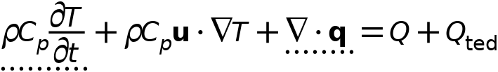



#### Heat Conduction, Solid

Settings

| **Description** | **Value** |
| --- | --- |
| Thermal conductivity | From material |

#### Thermodynamics, Solid

Settings

| **Description** | **Value** |
| --- | --- |
| Density | From material |
| Heat capacity at constant pressure | From material |

#### Coordinate System Selection

Settings

| **Description** | **Value** |
| --- | --- |
| Coordinate system | Global coordinate system |

#### Model Input

Settings

| **Description** | **Value** | **Unit** |
| --- | --- | --- |
| Volume reference temperature | Common model input |  |
| Absolute pressure | User defined |  |
| Absolute pressure | 1.0133E5 | Pa |

Properties from material

| **Property** | **Material** | **Property group** |
| --- | --- | --- |
| Thermal conductivity | battery mat | Basic |
| Density | battery mat | Basic |
| Heat capacity at constant pressure | battery mat | Basic |
| Thermal conductivity | Air | Basic |
| Density | Air | Basic |
| Heat capacity at constant pressure | Air | Ideal gas |

#### Variables

| **Name** | **Expression** | **Unit** | **Description** | **Selection** | **Details** |
| --- | --- | --- | --- | --- | --- |
| domflux.Tx | ht.dfluxx*ht.d | W/m² | Domain flux, x-component | Domains 1–2 |  |
| domflux.Ty | ht.dfluxy*ht.d | W/m² | Domain flux, y-component | Domains 1–2 |  |
| domflux.Tz | ht.dfluxz*ht.d | W/m² | Domain flux, z-component | Domains 1–2 |  |
| ht.chiT | 0 | 1/Pa | Isothermal compressibility coefficient | Domains 1–2 |  |
| ht.alphap | -d(ht.rho,T)/max(ht.rho,eps) | 1/K | Isobaric compressibility coefficient | Domains 1–2 |  |
| ht.DeltaH_add | integrate(ht.CpInt,ht.TInt,ht.DeltaH_Tlow,T) | J/kg | Sensible enthalpy | Domains 1–2 | + operation |
| ht.DeltaH_add_cst | ht.Cp*(T-ht.DeltaH_Tlow) | J/kg | Sensible enthalpy, constant material properties | Domains 1–2 | + operation |
| ht.H | ht.HRef+ht.DeltaH | J/kg | Enthalpy | Domains 1–2 | + operation |
| ht.H_cst | ht.HRef+ht.DeltaH_cst | J/kg | Enthalpy, constant material properties | Domains 1–2 | + operation |
| ht.Ei | ht.H | J/kg | Internal energy | Domains 1–2 | + operation |
| ht.Ei_cst | ht.H_cst | J/kg | Internal energy, constant material properties | Domains 1–2 | + operation |
| ht.Ek | 0.5*(ht.ux^2+ht.uy^2+ht.uz^2) | J/kg | Kinetic energy | Domains 1–2 | + operation |
| ht.dfluxx | -ht.k_effxx*Tx-ht.k_effxy*Ty-ht.k_effxz*Tz | W/m² | Conductive heat flux, x-component | Domains 1–2 | + operation |
| ht.dfluxy | -ht.k_effyx*Tx-ht.k_effyy*Ty-ht.k_effyz*Tz | W/m² | Conductive heat flux, y-component | Domains 1–2 | + operation |
| ht.dfluxz | -ht.k_effzx*Tx-ht.k_effzy*Ty-ht.k_effzz*Tz | W/m² | Conductive heat flux, z-component | Domains 1–2 | + operation |
| ht.dfluxtestx | -ht.k_effxx*test(Tx)-ht.k_effxy*test(Ty)-ht.k_effxz*test(Tz) | W/m² | Conductive heat flux, x-component | Domains 1–2 | + operation |
| ht.dfluxtesty | -ht.k_effyx*test(Tx)-ht.k_effyy*test(Ty)-ht.k_effyz*test(Tz) | W/m² | Conductive heat flux, y-component | Domains 1–2 | + operation |
| ht.dfluxtestz | -ht.k_effzx*test(Tx)-ht.k_effzy*test(Ty)-ht.k_effzz*test(Tz) | W/m² | Conductive heat flux, z-component | Domains 1–2 | + operation |
| ht.cfluxx | ht.rho*ht.ux*ht.Ei | W/m² | Convective heat flux, x-component | Domains 1–2 | + operation |
| ht.cfluxy | ht.rho*ht.uy*ht.Ei | W/m² | Convective heat flux, y-component | Domains 1–2 | + operation |
| ht.cfluxz | ht.rho*ht.uz*ht.Ei | W/m² | Convective heat flux, z-component | Domains 1–2 | + operation |
| ht.tefluxx | ht.dfluxx+ht.thfluxx | W/m² | Total energy flux, x-component | Domains 1–2 | + operation |
| ht.tefluxy | ht.dfluxy+ht.thfluxy | W/m² | Total energy flux, y-component | Domains 1–2 | + operation |
| ht.tefluxz | ht.dfluxz+ht.thfluxz | W/m² | Total energy flux, z-component | Domains 1–2 | + operation |
| ht.teflux_cstx | ht.dfluxx+ht.thflux_cstx | W/m² | Total energy flux, constant material properties, x-component | Domains 1–2 | + operation |
| ht.teflux_csty | ht.dfluxy+ht.thflux_csty | W/m² | Total energy flux, constant material properties, y-component | Domains 1–2 | + operation |
| ht.teflux_cstz | ht.dfluxz+ht.thflux_cstz | W/m² | Total energy flux, constant material properties, z-component | Domains 1–2 | + operation |
| ht.thfluxx | ht.rho*ht.ux*ht.H0 | W/m² | Total enthalpy flux, x-component | Domains 1–2 | + operation |
| ht.thfluxy | ht.rho*ht.uy*ht.H0 | W/m² | Total enthalpy flux, y-component | Domains 1–2 | + operation |
| ht.thfluxz | ht.rho*ht.uz*ht.H0 | W/m² | Total enthalpy flux, z-component | Domains 1–2 | + operation |
| ht.thflux_cstx | ht.rho*ht.ux*ht.H0_cst | W/m² | Total enthalpy flux, constant material properties, x-component | Domains 1–2 | + operation |
| ht.thflux_csty | ht.rho*ht.uy*ht.H0_cst | W/m² | Total enthalpy flux, constant material properties, y-component | Domains 1–2 | + operation |
| ht.thflux_cstz | ht.rho*ht.uz*ht.H0_cst | W/m² | Total enthalpy flux, constant material properties, z-component | Domains 1–2 | + operation |
| ht.ndflux_u | -uflux_spatial(T)/up(ht.varIntSpa) | W/m² | Internal normal conductive heat flux, upside | Boundaries 6–11 | + operation |
| ht.ndflux_d | -dflux_spatial(T)/down(ht.varIntSpa) | W/m² | Internal normal conductive heat flux, downside | Boundaries 6–11 | + operation |
| ht.ndflux_d | -dflux_spatial(T)/down(ht.varIntSpa) | W/m² | Internal normal conductive heat flux, downside | Boundaries 1–5, 12 | + operation |
| ht.dEiInt | ht.solid1.dEiInt | W | Total accumulated heat rate | Global | + operation |
| ht.dEiInt_cst | ht.solid1.dEiInt_cst | W | Total accumulated heat rate, constant material properties | Global | + operation |
| ht.dEi0Int | ht.solid1.dEi0Int | W | Total accumulated energy rate | Global | + operation |
| ht.dEi0Int_cst | ht.solid1.dEi0Int_cst | W | Total accumulated energy rate, constant material properties | Global | + operation |
| ht.Wstr | ht.pA*(d(ht.ux,x)+d(ht.uy,y)+d(ht.uz,z)) | W/m³ | Total stress power | Domains 1–2 | + operation |
| ht.WstrInt | ht.solid1.WstrInt | W | Total stress power | Global | + operation |
| ht.WstrInt_cst | ht.solid1.WstrInt_cst | W | Total stress power, constant material properties | Global | + operation |
| ht.WInt | ht.solid1.WInt | W | Total work source | Global | + operation |
| ht.WInt_cst | ht.solid1.WInt_cst | W | Total work source, constant material properties | Global | + operation |
| ht.rho | material.rho | kg/m³ | Density | Domains 1–2 | Meta |
| ht.kxx | material.k11 | W/(m·K) | Thermal conductivity, xx-component | Domains 1–2 | Meta |
| ht.kyx | material.k21 | W/(m·K) | Thermal conductivity, yx-component | Domains 1–2 | Meta |
| ht.kzx | material.k31 | W/(m·K) | Thermal conductivity, zx-component | Domains 1–2 | Meta |
| ht.kxy | material.k12 | W/(m·K) | Thermal conductivity, xy-component | Domains 1–2 | Meta |
| ht.kyy | material.k22 | W/(m·K) | Thermal conductivity, yy-component | Domains 1–2 | Meta |
| ht.kzy | material.k32 | W/(m·K) | Thermal conductivity, zy-component | Domains 1–2 | Meta |
| ht.kxz | material.k13 | W/(m·K) | Thermal conductivity, xz-component | Domains 1–2 | Meta |
| ht.kyz | material.k23 | W/(m·K) | Thermal conductivity, yz-component | Domains 1–2 | Meta |
| ht.kzz | material.k33 | W/(m·K) | Thermal conductivity, zz-component | Domains 1–2 | Meta |
| ht.Cp | material.Cp | J/(kg·K) | Heat capacity at constant pressure | Domains 1–2 | Meta |
| ht.solid1.pref | 1[atm] | Pa | Reference pressure level | Domains 1–2 |  |
| ht.k_iso | if(material.k12==0&&material.k13==0&&material.k21==0&&material.k22==material.k11&&material.k23==0&&material.k31==0&&material.k32==0&&material.k33==material.k11,material.k11,error('Failed to evaluate an isotropic value of an anisotropic tensor')) | W/(m·K) | Thermal conductivity, isotropic value | Domains 1–2 | Meta |
| ht.pA | ht.pref | Pa | Absolute pressure | Domains 1–2 |  |
| ht.C_eff | ht.rho*ht.Cp | J/(m³·K) | Effective volumetric heat capacity | Domains 1–2 |  |
| ht.cellPe | 0.5*ht.rho*ht.Cp*h*sqrt(ht.ux^2+ht.uy^2+ht.uz^2)/ht.kmean | 1 | Cell Péclet number | Domains 1–2 |  |
| ht.ux | 0 | m/s | Velocity field, x-component | Domains 1–2 | + operation |
| ht.uy | 0 | m/s | Velocity field, y-component | Domains 1–2 | + operation |
| ht.uz | 0 | m/s | Velocity field, z-component | Domains 1–2 | + operation |
| ht.Qmet | 0 | W/m³ | Metabolic heat source | Domains 1–2 | + operation |
| ht.rhoInit | subst(ht.rho,T,ht.Tinit,minput.pA,ht.pref) | kg/m³ | Initial density | Domains 1–2 |  |
| ht.rho_eff | ht.rho | kg/m³ | Effective density | Domains 1–2 |  |
| ht.k_effxx | ht.kxx | W/(m·K) | Effective thermal conductivity, xx-component | Domains 1–2 |  |
| ht.k_effyx | ht.kyx | W/(m·K) | Effective thermal conductivity, yx-component | Domains 1–2 |  |
| ht.k_effzx | ht.kzx | W/(m·K) | Effective thermal conductivity, zx-component | Domains 1–2 |  |
| ht.k_effxy | ht.kxy | W/(m·K) | Effective thermal conductivity, xy-component | Domains 1–2 |  |
| ht.k_effyy | ht.kyy | W/(m·K) | Effective thermal conductivity, yy-component | Domains 1–2 |  |
| ht.k_effzy | ht.kzy | W/(m·K) | Effective thermal conductivity, zy-component | Domains 1–2 |  |
| ht.k_effxz | ht.kxz | W/(m·K) | Effective thermal conductivity, xz-component | Domains 1–2 |  |
| ht.k_effyz | ht.kyz | W/(m·K) | Effective thermal conductivity, yz-component | Domains 1–2 |  |
| ht.k_effzz | ht.kzz | W/(m·K) | Effective thermal conductivity, zz-component | Domains 1–2 |  |
| ht.kappaTxx | 0 | W/(m·K) | Turbulent thermal conductivity, xx-component | Domains 1–2 |  |
| ht.kappaTyx | 0 | W/(m·K) | Turbulent thermal conductivity, yx-component | Domains 1–2 |  |
| ht.kappaTzx | 0 | W/(m·K) | Turbulent thermal conductivity, zx-component | Domains 1–2 |  |
| ht.kappaTxy | 0 | W/(m·K) | Turbulent thermal conductivity, xy-component | Domains 1–2 |  |
| ht.kappaTyy | 0 | W/(m·K) | Turbulent thermal conductivity, yy-component | Domains 1–2 |  |
| ht.kappaTzy | 0 | W/(m·K) | Turbulent thermal conductivity, zy-component | Domains 1–2 |  |
| ht.kappaTxz | 0 | W/(m·K) | Turbulent thermal conductivity, xz-component | Domains 1–2 |  |
| ht.kappaTyz | 0 | W/(m·K) | Turbulent thermal conductivity, yz-component | Domains 1–2 |  |
| ht.kappaTzz | 0 | W/(m·K) | Turbulent thermal conductivity, zz-component | Domains 1–2 |  |
| ht.kmean | (ht.k_effxx+ht.k_effyy+ht.k_effzz)/3 | W/(m·K) | Mean effective thermal conductivity | Domains 1–2 |  |
| ht.alphaTdxx | ht.k_effxx/ht.C_eff | m²/s | Thermal diffusivity, xx-component | Domains 1–2 |  |
| ht.alphaTdyx | ht.k_effyx/ht.C_eff | m²/s | Thermal diffusivity, yx-component | Domains 1–2 |  |
| ht.alphaTdzx | ht.k_effzx/ht.C_eff | m²/s | Thermal diffusivity, zx-component | Domains 1–2 |  |
| ht.alphaTdxy | ht.k_effxy/ht.C_eff | m²/s | Thermal diffusivity, xy-component | Domains 1–2 |  |
| ht.alphaTdyy | ht.k_effyy/ht.C_eff | m²/s | Thermal diffusivity, yy-component | Domains 1–2 |  |
| ht.alphaTdzy | ht.k_effzy/ht.C_eff | m²/s | Thermal diffusivity, zy-component | Domains 1–2 |  |
| ht.alphaTdxz | ht.k_effxz/ht.C_eff | m²/s | Thermal diffusivity, xz-component | Domains 1–2 |  |
| ht.alphaTdyz | ht.k_effyz/ht.C_eff | m²/s | Thermal diffusivity, yz-component | Domains 1–2 |  |
| ht.alphaTdzz | ht.k_effzz/ht.C_eff | m²/s | Thermal diffusivity, zz-component | Domains 1–2 |  |
| ht.alphaTdMean | ht.kmean/ht.C_eff | m²/s | Mean thermal diffusivity | Domains 1–2 |  |
| ht.gradTx | Tx | K/m | Temperature gradient, x-component | Domains 1–2 |  |
| ht.gradTy | Ty | K/m | Temperature gradient, y-component | Domains 1–2 |  |
| ht.gradTz | Tz | K/m | Temperature gradient, z-component | Domains 1–2 |  |
| ht.gradTmag | sqrt(ht.gradTx^2+ht.gradTy^2+ht.gradTz^2) | K/m | Temperature gradient magnitude | Domains 1–2 |  |
| ht.pref | ht.solid1.pref | Pa | Reference pressure level | Domains 1–2 |  |
| ht.DeltaH_Tlow | ht.Tref | K | Temperature lower bound for enthalpy evaluation | Domains 1–2 |  |
| ht.DeltaH_plow | ht.pref | Pa | Pressure lower bound for enthalpy evaluation | Domains 1–2 |  |
| ht.dHdp | 0 | m³/kg | Intermediate variable | Domains 1–2 |  |
| ht.mujtT | 0 | K/Pa | Isothermal Joule-Thomson coefficient | Domains 1–2 |  |
| ht.alphapT | ht.alphap*T | 1 | Help variable | Domains 1–2 |  |
| ht.dEi | material.dt(ht.rho*ht.Ei) | W/m³ | Total accumulated heat rate density | Domains 1–2 |  |
| ht.dEi_cst | material.dt(ht.rho*ht.Ei_cst) | W/m³ | Total accumulated heat rate density, constant material properties | Domains 1–2 |  |
| ht.dEi0 | material.dt(ht.rho*ht.Ei0) | W/m³ | Total accumulated energy rate density | Domains 1–2 |  |
| ht.dEi0_cst | material.dt(ht.rho*ht.Ei0_cst) | W/m³ | Total accumulated energy rate density, constant material properties | Domains 1–2 |  |
| ht.solid1.dEiInt | ht.solid1.intDom((ht.dEi-ht.Qm*ht.Ei)*ht.varIntSpa) | W | Total accumulated heat rate | Global |  |
| ht.solid1.dEiInt_cst | ht.solid1.intDom((ht.dEi_cst-ht.Qm*ht.Ei_cst)*ht.varIntSpa) | W | Total accumulated heat rate, constant material properties | Global |  |
| ht.solid1.dEi0Int | ht.solid1.intDom((ht.dEi0-ht.Qm*ht.H)*ht.varIntSpa) | W | Total accumulated energy rate | Global |  |
| ht.solid1.dEi0Int_cst | ht.solid1.intDom((ht.dEi0_cst-ht.Qm*ht.H_cst)*ht.varIntSpa) | W | Total accumulated energy rate, constant material properties | Global |  |
| ht.solid1.QInt | ht.solid1.intDom(ht.Qtot*ht.varIntSpa)+ht.solid1.intIntLine(ht.Qltot*ht.varIntSpa)+ht.intLine(subst(ht.Qlrtot,ht.id,isdefined(ht.solid1.id))*ht.varIntSpa)+ht.solid1.intIntPnt(ht.Qptot)+ht.intPnt(subst(ht.Qprtot,ht.id,isdefined(ht.solid1.id)))-ht.solid1.intIntBnd(ht.ndflux_u*up(ht.varIntSpa)+ht.ndflux_d*down(ht.varIntSpa)) | W | Total heat source | Global |  |
| ht.solid1.QInt_cst | ht.solid1.intDom(ht.Qtot*ht.varIntSpa)+ht.solid1.intIntLine(ht.Qltot*ht.varIntSpa)+ht.intLine(subst(ht.Qlrtot,ht.id,isdefined(ht.solid1.id))*ht.varIntSpa)+ht.solid1.intIntPnt(ht.Qptot)+ht.intPnt(subst(ht.Qprtot,ht.id,isdefined(ht.solid1.id)))-ht.solid1.intIntBnd(ht.ndflux_u*up(ht.varIntSpa)+ht.ndflux_d*down(ht.varIntSpa)) | W | Total heat source, constant material properties | Global |  |
| ht.solid1.WstrInt | ht.solid1.intDom(ht.Wstr*ht.varIntSpa) | W | Total stress power | Global |  |
| ht.solid1.WstrInt_cst | ht.solid1.intDom(ht.Wstr*ht.varIntSpa) | W | Total stress power, constant material properties | Global |  |
| ht.solid1.WInt | ht.solid1.intDom(ht.Wtot*ht.varIntSpa)+ht.solid1.intBndUp(ht.WBndTot_u*up(ht.varIntSpa))+ht.solid1.intBndDown(ht.WBndTot_d*down(ht.varIntSpa)) | W | Total work source | Global |  |
| ht.solid1.WInt_cst | ht.solid1.intDom(ht.Wtot*ht.varIntSpa)+ht.solid1.intBndUp(ht.WBndTot_u*up(ht.varIntSpa))+ht.solid1.intBndDown(ht.WBndTot_d*down(ht.varIntSpa)) | W | Total work source, constant material properties | Global |  |
| ht.solid1.ntfluxInt | ht.solid1.intExtBnd(ht.ntflux*ht.varIntSpa)+ht.solid1.intExtBndUp(ht.ntflux_u*up(ht.varIntSpa))+ht.solid1.intExtBndDown(ht.ntflux_d*down(ht.varIntSpa))+ht.solid1.intIntBnd(ht.ncflux_u*up(ht.varIntSpa)+ht.ncflux_d*down(ht.varIntSpa)) | W | Total net heat rate | Global |  |
| ht.solid1.ntfluxInt_cst | ht.solid1.intExtBnd(ht.ntflux_cst*ht.varIntSpa)+ht.solid1.intExtBndUp(ht.ntflux_cst_u*up(ht.varIntSpa))+ht.solid1.intExtBndDown(ht.ntflux_cst_d*down(ht.varIntSpa))+ht.solid1.intIntBnd(ht.ncflux_u*up(ht.varIntSpa)+ht.ncflux_d*down(ht.varIntSpa)) | W | Total net heat rate, constant material properties | Global |  |
| ht.solid1.ntefluxInt | ht.solid1.intExtBnd(ht.nteflux*ht.varIntSpa)+ht.solid1.intExtBndUp(ht.nteflux_u*up(ht.varIntSpa))+ht.solid1.intExtBndDown(ht.nteflux_d*down(ht.varIntSpa))+ht.solid1.intIntBnd(ht.nthflux_u*up(ht.varIntSpa)+ht.nthflux_d*down(ht.varIntSpa)) | W | Total net energy rate | Global |  |
| ht.solid1.ntefluxInt_cst | ht.solid1.intExtBnd(ht.nteflux_cst*ht.varIntSpa)+ht.solid1.intExtBndUp(ht.nteflux_cst_u*up(ht.varIntSpa))+ht.solid1.intExtBndDown(ht.nteflux_cst_d*down(ht.varIntSpa))+ht.solid1.intIntBnd(ht.nthflux_cst_u*up(ht.varIntSpa)+ht.nthflux_cst_d*down(ht.varIntSpa)) | W | Total net energy rate, constant material properties | Global |  |
| ht.solid1.heatBalance | ht.solid1.dEiInt+ht.solid1.ntfluxInt+ht.solid1.WstrInt-ht.solid1.QInt | W | Heat balance | Global |  |
| ht.solid1.heatBalance_cst | ht.solid1.dEiInt_cst+ht.solid1.ntfluxInt_cst+ht.solid1.WstrInt_cst-ht.solid1.QInt_cst | W | Heat balance, constant material properties | Global |  |
| ht.solid1.energyBalance | ht.solid1.dEi0Int+ht.solid1.ntefluxInt-ht.solid1.WInt-ht.solid1.QInt | W | Energy balance | Global |  |
| ht.solid1.energyBalance_cst | ht.solid1.dEi0Int_cst+ht.solid1.ntefluxInt_cst-ht.solid1.WInt_cst-ht.solid1.QInt_cst | W | Energy balance, constant material properties | Global |  |
| ht.Tradu | ht.Tu | K | Upside temperature | Domains 1–2 |  |
| ht.Tradu | ht.Tu | K | Upside temperature | Boundaries 1–12 |  |
| ht.Tradd | ht.Td | K | Downside temperature | Domains 1–2 |  |
| ht.Tradd | ht.Td | K | Downside temperature | Boundaries 1–12 |  |
| ht.timeDerivative | material.dt(T) | K/s | Temperature, first time derivative | Domains 1–2 |  |
| ht.gamma | 1 | 1 | Ratio of specific heats | Domains 1–2 |  |
| ht.Trho | ht.Tref | K | Temperature for density evaluation | Domains 1–2 |  |
| ht.CpInt | subst(material.Cp,ht.solid1.minput_pressure,ht.pref,ht.solid1.minput_temperature,ht.TInt) | J/(kg·K) | Specific heat capacity for integration | Domains 1–2 | Meta |
| ht.Cp_ref | subst(material.Cp,ht.solid1.minput_pressure,ht.pref,ht.solid1.minput_temperature,ht.Tref) | J/(kg·K) | Reference heat capacity | Domains 1–2 | Meta |

#### Shape functions

| **Name** | **Shape function** | **Unit** | **Description** | **Shape frame** | **Selection** |
| --- | --- | --- | --- | --- | --- |
| T | Lagrange (Quadratic) | K | Temperature | Material | Domains 1–2 |
| T | Lagrange (Quadratic) | K | Temperature | Spatial | Domains 1–2 |
| T | Lagrange (Quadratic) | K | Temperature | Geometry | Domains 1–2 |
| T | Lagrange (Quadratic) | K | Temperature | Mesh | Domains 1–2 |

#### Weak Expressions

| **Weak expression** | **Integration order** | **Integration frame** | **Selection** |
| --- | --- | --- | --- |
| (ht.dfluxx*test(Tx)+ht.dfluxy*test(Ty)+ht.dfluxz*test(Tz))*ht.d | 4 | Spatial | Domains 1–2 |
| -ht.C_eff*ht.timeDerivative*test(T)*ht.d | 4 | Spatial | Domains 1–2 |

### Initial Values 1



Initial Values 1

Selection

|  |  |
| --- | --- |
| Geometric entity level | Domain |
| Selection | Geometry geom1: Dimension 3: All domains |

#### Initial Values

Settings

| **Description** | **Value** | **Unit** |
| --- | --- | --- |
| Temperature | User defined |  |
| Temperature | 328.15 | K |

#### Variables

| **Name** | **Expression** | **Unit** | **Description** | **Selection** |
| --- | --- | --- | --- | --- |
| ht.Tinit | 328.15[K] | K | Initial temperature | Domains 1–2 |

### Thermal Insulation 1



Thermal Insulation 1

Selection

|  |  |
| --- | --- |
| Geometric entity level | Boundary |
| Selection | Geometry geom1: Dimension 2: All boundaries |

Equations



#### Variables

| **Name** | **Expression** | **Unit** | **Description** | **Selection** |
| --- | --- | --- | --- | --- |
| ht.ins1.ntfluxInt | ht.ins1.intExtBnd(ht.ntflux*ht.varIntSpa)+ht.ins1.intIntBnd(ht.ncflux_u*up(ht.varIntSpa)+ht.ncflux_d*down(ht.varIntSpa)) | W | Total net heat rate | Global |
| ht.ins1.ntfluxInt_cst | ht.ins1.intExtBnd(ht.ntflux*ht.varIntSpa)+ht.ins1.intIntBnd(ht.ncflux_u*up(ht.varIntSpa)+ht.ncflux_d*down(ht.varIntSpa)) | W | Total net heat rate, constant material properties | Global |
| ht.ins1.ntefluxInt | ht.ins1.intExtBnd(ht.nteflux*ht.varIntSpa)+ht.ins1.intIntBnd(ht.nthflux_u*up(ht.varIntSpa)+ht.nthflux_d*down(ht.varIntSpa)) | W | Total net energy rate | Global |
| ht.ins1.ntefluxInt_cst | ht.ins1.intExtBnd(ht.nteflux_cst*ht.varIntSpa)+ht.ins1.intIntBnd(ht.nthflux_cst_u*up(ht.varIntSpa)+ht.nthflux_cst_d*down(ht.varIntSpa)) | W | Total net energy rate, constant material properties | Global |
| ht.ins1.ntfluxInt_u | ht.ins1.intIntBnd(ht.ntflux_u*up(ht.varIntSpa)) | W | Total net heat rate, upside | Global |
| ht.ins1.ntfluxInt_cst_u | ht.ins1.intIntBnd(ht.ntflux_u*up(ht.varIntSpa)) | W | Total net heat rate, constant material properties, upside | Global |
| ht.ins1.ntefluxInt_u | ht.ins1.intIntBnd(ht.nteflux_u*up(ht.varIntSpa)) | W | Total net energy rate, upside | Global |
| ht.ins1.ntefluxInt_cst_u | ht.ins1.intIntBnd(ht.nteflux_cst_u*up(ht.varIntSpa)) | W | Total net energy rate, constant material properties, upside | Global |
| ht.ins1.ntfluxInt_d | ht.ins1.intIntBnd(ht.ntflux_d*down(ht.varIntSpa)) | W | Total net heat rate, downside | Global |
| ht.ins1.ntfluxInt_cst_d | ht.ins1.intIntBnd(ht.ntflux_d*down(ht.varIntSpa)) | W | Total net heat rate, constant material properties, downside | Global |
| ht.ins1.ntefluxInt_d | ht.ins1.intIntBnd(ht.nteflux_d*down(ht.varIntSpa)) | W | Total net energy rate, downside | Global |
| ht.ins1.ntefluxInt_cst_d | ht.ins1.intIntBnd(ht.nteflux_cst_d*down(ht.varIntSpa)) | W | Total net energy rate, constant material properties, downside | Global |
| ht.ins1.Tave | nojac(ht.ins1.intBnd(ht.varIntSpa*ht.rho*ht.Cp*T*max(abs(ht.ux*ht.nxmesh+ht.uy*ht.nymesh+ht.uz*ht.nzmesh),eps)))/nojac(ht.ins1.intBnd(ht.varIntSpa*ht.rho*ht.Cp*max(abs(ht.ux*ht.nxmesh+ht.uy*ht.nymesh+ht.uz*ht.nzmesh),eps))) | K | Weighted average temperature | Global |

#### Shape functions

| **Name** | **Shape function** | **Unit** | **Description** | **Shape frame** | **Selection** | **Details** |
| --- | --- | --- | --- | --- | --- | --- |
| T | Lagrange (Quadratic) | K | Temperature | Spatial | No boundaries | Slit |
| T | Lagrange (Quadratic) | K | Temperature | Material | No boundaries | Slit |
| T | Lagrange (Quadratic) | K | Temperature | Geometry | No boundaries | Slit |
| T | Lagrange (Quadratic) | K | Temperature | Mesh | No boundaries | Slit |

## Mesh 1

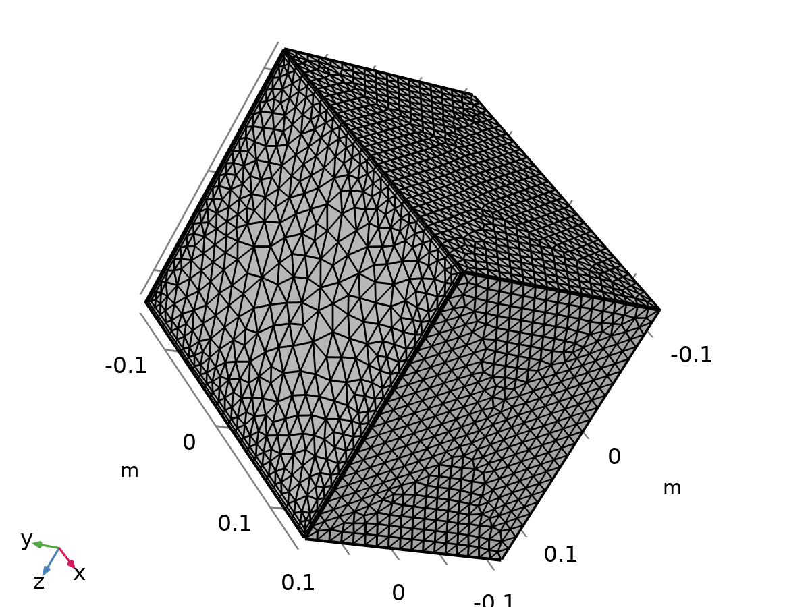

Mesh 1

Mesh statistics

| **Description** | **Value** |
| --- | --- |
| Status | Complete mesh |
| Mesh vertices | 15501 |
| Tetrahedra | 60795 |
| Prisms | 7616 |
| Triangles | 6448 |
| Quads | 376 |
| Edge elements | 364 |
| Vertex elements | 16 |
| Number of elements | 68411 |
| Minimum element quality | 0.1698 |
| Average element quality | 0.6955 |
| Element volume ratio | 0.0084495 |
| Mesh volume | 0.015 m³ |

### Size (size)

Settings

| **Description** | **Value** |
| --- | --- |
| Calibrate for | Fluid dynamics |
| Maximum element size | 0.0224 |
| Minimum element size | 9.408E-4 |
| Curvature factor | 0.7 |
| Resolution of narrow regions | 0.6 |
| Maximum element growth rate | 1.2 |
| Predefined size | Coarse |
| Custom element size | Custom |

### Size 1 (size1)

Selection

|  |  |
| --- | --- |
| Geometric entity level | Boundary |
| Selection | Geometry geom1: Dimension 2: Boundaries 1, 3–4, 12 |

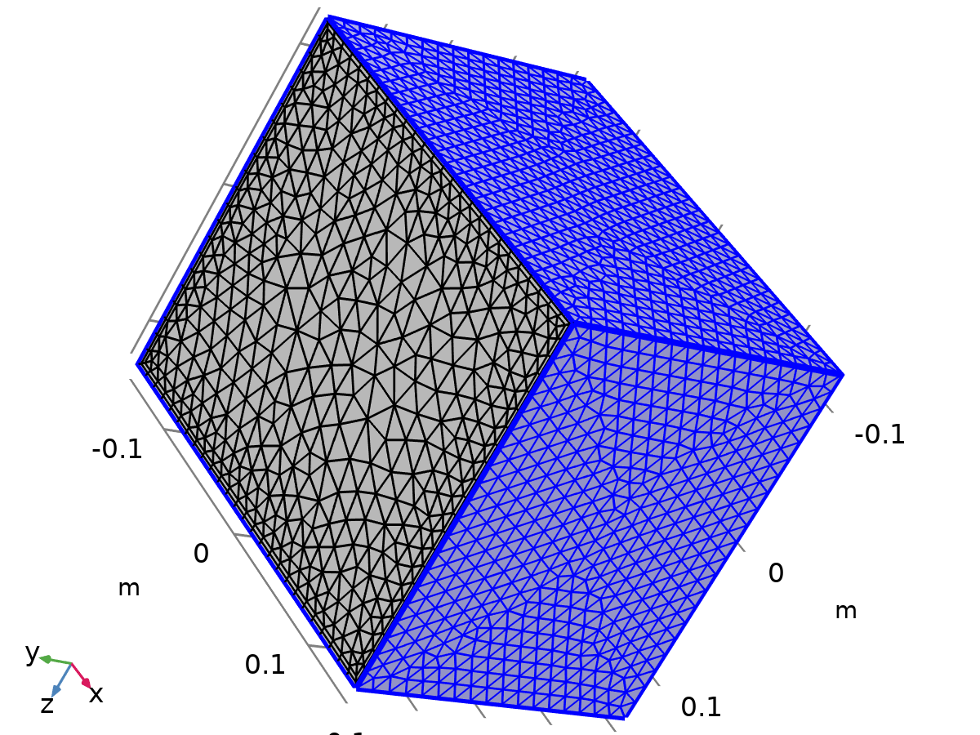

Size 1

Settings

| **Description** | **Value** |
| --- | --- |
| Calibrate for | Fluid dynamics |
| Maximum element size | 0.0119 |
| Minimum element size | 0.00224 |
| Curvature factor | 0.5 |
| Resolution of narrow regions | 0.8 |
| Maximum element growth rate | 1.13 |
| Predefined size | Fine |

### Size 2 (size2)

Selection

|  |  |
| --- | --- |
| Geometric entity level | Boundary |
| Selection | Geometry geom1: Dimension 2: Boundaries 6–11 |

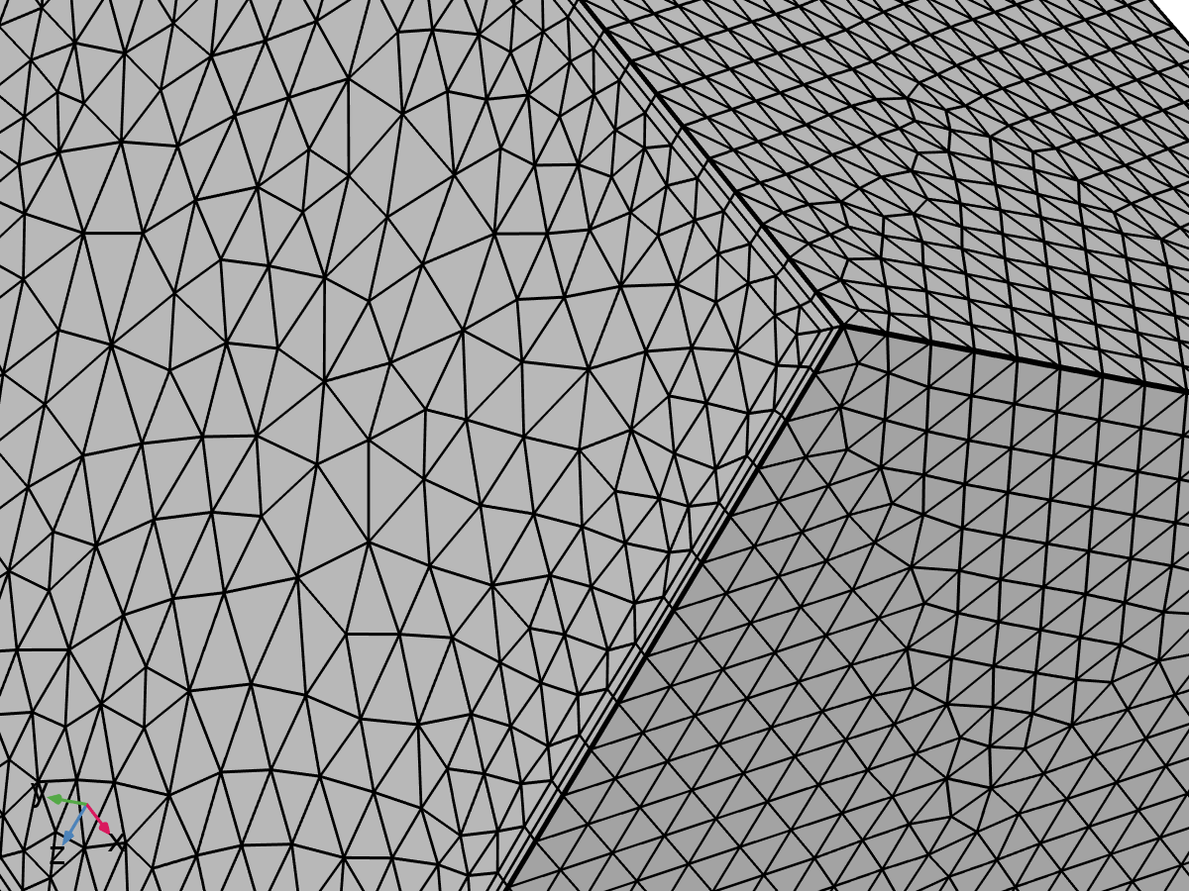

Size 2

Settings

| **Description** | **Value** |
| --- | --- |
| Calibrate for | Fluid dynamics |
| Maximum element size | 0.01173 |
| Minimum element size | 3.519E-4 |
| Curvature factor | 0.7 |
| Curvature factor | Off |
| Resolution of narrow regions | 0.6 |
| Resolution of narrow regions | Off |
| Maximum element growth rate | 1.2 |
| Maximum element growth rate | Off |
| Predefined size | Coarse |
| Custom element size | Custom |

### Corner Refinement 1 (cr1)

Selection

|  |  |
| --- | --- |
| Geometric entity level | Domain |
| Selection | Geometry geom1: Dimension 3: Domains 1–2 |

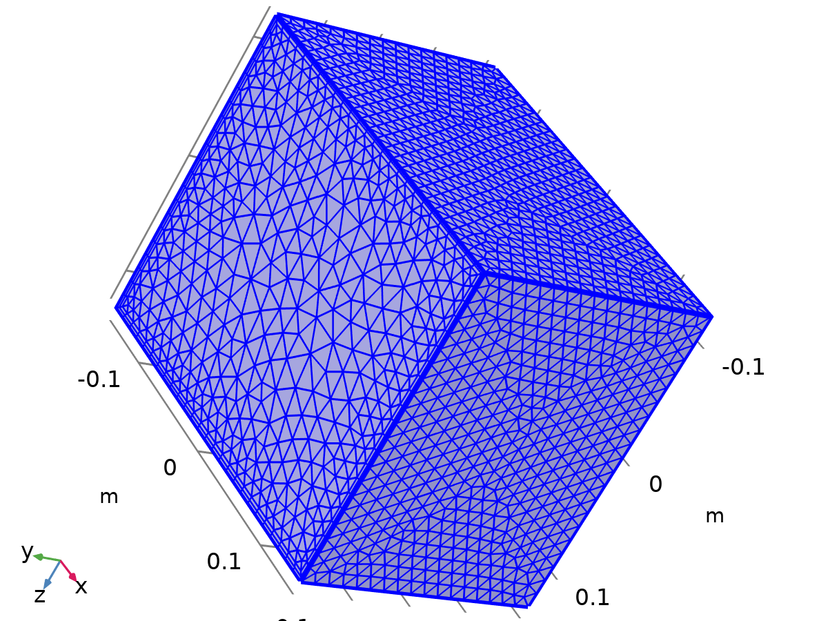

Corner Refinement 1

### Free Tetrahedral 1 (ftet1)

Selection

|  |  |
| --- | --- |
| Geometric entity level | Domain |
| Selection | Remaining |



Free Tetrahedral 1

Settings

| **Description** | **Value** |
| --- | --- |
| Avoid inverted curved elements | On |

Information

| **Description** | **Value** |
| --- | --- |
| Last build time | < 1 second |
| Built with | COMSOL 6.3.0.335 (win64), Apr 28, 2025, 10:49:47 AM |

### Boundary Layers 1 (bl1)

Selection

|  |  |
| --- | --- |
| Geometric entity level | Domain |
| Selection | Geometry geom1: Dimension 3: Domains 1–2 |



Boundary Layers 1

Information

| **Description** | **Value** |
| --- | --- |
| Handling of sharp edges | Trimming |
| Last build time | 3 seconds |
| Built with | COMSOL 6.3.0.335 (win64), Apr 28, 2025, 10:49:50 AM |

#### Boundary Layer Properties 1 (blp1)

Selection

|  |  |
| --- | --- |
| Geometric entity level | Boundary |
| Selection | Geometry geom1: Dimension 2: Boundaries 1, 3–4, 12 |



Boundary Layer Properties 1

Settings

| **Description** | **Value** |
| --- | --- |
| Number of layers | 2 |
| Thickness adjustment factor | 5 |

# Study 1

Computation information

|  |  |
| --- | --- |
| Computation time |  |

## Time Dependent

| **Times** | **Unit** |
| --- | --- |
| range(0,5,600) | s |

Study settings

| **Description** | **Value** |
| --- | --- |
| Include geometric nonlinearity | Off |

Study settings

| **Description** | **Value** |
| --- | --- |
| Output times | {0, 5, 10, 15, 20, 25, 30, 35, 40, 45, 50, 55, 60, 65, 70, 75, 80, 85, 90, 95, 100, 105, 110, 115, 120, 125, 130, 135, 140, 145, 150, 155, 160, 165, 170, 175, 180, 185, 190, 195, 200, 205, 210, 215, 220, 225, 230, 235, 240, 245, 250, 255, 260, 265, 270, 275, 280, 285, 290, 295, 300, 305, 310, 315, 320, 325, 330, 335, 340, 345, 350, 355, 360, 365, 370, 375, 380, 385, 390, 395, 400, 405, 410, 415, 420, 425, 430, 435, 440, 445, 450, 455, 460, 465, 470, 475, 480, 485, 490, 495, 500, 505, 510, 515, 520, 525, 530, 535, 540, 545, 550, 555, 560, 565, 570, 575, 580, 585, 590, 595, 600} |

Physics and variables selection

| **Key** | **Solve for** |
| --- | --- |
| Laminar Flow (spf) | On |
| Heat Transfer in Solids (ht) | On |

Store in output

| **Interface** | **Output** | **Selection** |
| --- | --- | --- |
| Laminar Flow (spf) | Physics controlled |  |
| Heat Transfer in Solids (ht) | Physics controlled |  |

Mesh selection

| **Component** | **Mesh** |
| --- | --- |
| Component 1 | Mesh 1 |

## Solver Configurations

### Solution 1

#### Compile Equations: Time Dependent (st1)

Study and step

| **Description** | **Value** |
| --- | --- |
| Use study | Study 1 |
| Use study step | Time Dependent |

Log

<---- Compile Equations: Time Dependent in Study 1/Solution 1 (sol1) -----------

Started at Apr 28, 2025, 1:17:23 PM.

Geometry shape function: Linear Lagrange

Running on Intel64 Family 6 Model 140 Stepping 1, GenuineIntel.

Using 1 socket with 4 cores in total on DESKTOP-J7DCJNQ.

Available memory: 7.87 GB.

Time: 3 s.

Physical memory: 1.34 GB

Virtual memory: 2.43 GB

Ended at Apr 28, 2025, 1:17:27 PM.

----- Compile Equations: Time Dependent in Study 1/Solution 1 (sol1) ---------->

#### Dependent Variables 1 (v1)

General

| **Description** | **Value** |
| --- | --- |
| Defined by study step | Step 1: Time Dependent |

Initial value calculation constants

| **Constant name** | **Initial-value source** |
| --- | --- |
| t | {range(0, 5, 600)}[s] |
| timestep | 0.6[s] |

Log

<---- Dependent Variables 1 in Study 1/Solution 1 (sol1) -----------------------

Started at Apr 28, 2025, 1:17:27 PM.

Solution time: 0 s.

Physical memory: 1.36 GB

Virtual memory: 2.42 GB

Ended at Apr 28, 2025, 1:17:27 PM.

----- Dependent Variables 1 in Study 1/Solution 1 (sol1) ---------------------->

##### Pressure (comp1.p) (comp1_p)

General

| **Description** | **Value** |
| --- | --- |
| Field components | comp1.p |

##### Temperature (comp1.T) (comp1_T)

General

| **Description** | **Value** |
| --- | --- |
| Field components | comp1.T |
| Internal variables | {comp1.ht.dt2Inv_T, comp1.uflux.T, comp1.dflux.T} |

##### Velocity Field (comp1.u) (comp1_u)

General

| **Description** | **Value** |
| --- | --- |
| Field components | {comp1.u, comp1.v, comp1.w} |
| Internal variables | {comp1.spf.dt2Inv_u, comp1.spf.isFluidHasBeenSolved} |

#### Time-Dependent Solver 1 (t1)

General

| **Description** | **Value** |
| --- | --- |
| Defined by study step | Step 1: Time Dependent |
| Output times | {0, 5, 10, 15, 20, 25, 30, 35, 40, 45, 50, 55, 60, 65, 70, 75, 80, 85, 90, 95, 100, 105, 110, 115, 120, 125, 130, 135, 140, 145, 150, 155, 160, 165, 170, 175, 180, 185, 190, 195, 200, 205, 210, 215, 220, 225, 230, 235, 240, 245, 250, 255, 260, 265, 270, 275, 280, 285, 290, 295, 300, 305, 310, 315, 320, 325, 330, 335, 340, 345, 350, 355, 360, 365, 370, 375, 380, 385, 390, 395, 400, 405, 410, 415, 420, 425, 430, 435, 440, 445, 450, 455, 460, 465, 470, 475, 480, 485, 490, 495, 500, 505, 510, 515, 520, 525, 530, 535, 540, 545, 550, 555, 560, 565, 570, 575, 580, 585, 590, 595, 600} |
| Relative tolerance | 0.005 |

Absolute tolerance

| **Description** | **Value** |
| --- | --- |
| Tolerance factor | 0.05 |

Absolute tolerance

| **Field** | **Method** | **Tolerance method** | **Tolerance factor** | **Derivative tolerance method** | **Time derivative factor** | **Tolerance** | **Tolerance for time derivatives** |
| --- | --- | --- | --- | --- | --- | --- | --- |
| Pressure (comp1.p) | Scaled | Factor | 1 | Automatic | 1 | 0.001 | 0.001 |
| Temperature (comp1.T) | Use global | Factor | 0.1 | Automatic | 1 | 0.001 | 0.001 |
| Velocity Field (comp1.u) | Use global | Factor | 0.1 | Automatic | 1 | 0.001 | 0.001 |

Time stepping

| **Description** | **Value** |
| --- | --- |
| Maximum BDF order | 2 |
| Nonlinear controller | On |
| Fraction of initial step for Backward Euler | 0.01 |
| Error estimation | Exclude algebraic |

Log

<---- Time-Dependent Solver 1 in Study 1/Solution 1 (sol1) ---------------------

Started at Apr 28, 2025, 1:17:27 PM.

Time-dependent solver (BDF)

Number of degrees of freedom solved for: 179724 (plus 85870 internal DOFs).

Symmetric matrices found.

Scales for dependent variables:

Temperature (comp1.T): 3.3e+02

Orthonormal null-space function used.

Nonsymmetric matrix found.

Scales for dependent variables:

Pressure (comp1.p): 0.22

Velocity Field (comp1.u): 0.2

Orthonormal null-space function used.

Nonsymmetric matrix found.

Step        Time    Stepsize      Res  Jac  Sol Order Tfail NLfail   LinErr   LinRes

   0           0           - out   66   10   66                  0

                   Group #1:       33    5   33                     7.2e-16  4.8e-16

                   Group #2:       33    5   33                     2.1e-14  2.8e-15

   1    0.012097  9.7236e-05       82   12   82     1     0      0

                   Group #1:       41    6   41                     7.5e-16  4.9e-16

                   Group #2:       41    6   41                     8.9e-13  2.3e-13

   2    0.012194  9.7236e-05       98   14   98     1     0      0

                   Group #1:       49    7   49                     7.5e-16  4.9e-16

                   Group #2:       49    7   49                       8e-13  9.4e-14

Canceled

Solution time: 147 s. (2 minutes, 27 seconds)

Physical memory: 2.52 GB

Virtual memory: 4.34 GB

Ended at Apr 28, 2025, 1:19:54 PM.

----- Time-Dependent Solver 1 in Study 1/Solution 1 (sol1) -------------------->

##### Advanced (aDef)

Assembly settings

| **Description** | **Value** |
| --- | --- |
| Reuse sparsity pattern | On |

##### Segregated 1 (se1)

General

| **Description** | **Value** |
| --- | --- |
| Tolerance factor | 0.5 |
| Stabilization and acceleration | Anderson acceleration |
| Dimension of iteration space | 5 |
| Mixing parameter | 0.9 |
| Iteration delay | 1 |

###### Temperature (ss1)

General

| **Description** | **Value** |
| --- | --- |
| Variables | Temperature (comp1.T) |
| Linear solver | Direct, heat transfer variables (ht) |

Method and termination

| **Description** | **Value** |
| --- | --- |
| Damping factor | 0.8 |
| Jacobian update | Once per time step |

###### Velocity u, Pressure p (ss2)

General

| **Description** | **Value** |
| --- | --- |
| Variables | {Velocity Field (comp1.u), Pressure (comp1.p)} |
| Linear solver | Direct, fluid flow variables (spf) |

Method and termination

| **Description** | **Value** |
| --- | --- |
| Damping factor | 0.8 |
| Jacobian update | Once per time step |

###### Lower Limit 1 (ll1)

Lower limit

| **Description** | **Value** |
| --- | --- |
| Lower limits (field variables) | comp1.T 0 |

##### Direct, heat transfer variables (ht) (d1)

General

| **Description** | **Value** |
| --- | --- |
| Solver | PARDISO |
| Pivoting perturbation | 1E-13 |

##### Direct, fluid flow variables (spf) (d2)

General

| **Description** | **Value** |
| --- | --- |
| Solver | PARDISO |
| Pivoting perturbation | 1E-13 |

# Results

## Datasets

### Study 1/Solution 1

Solution

| **Description** | **Value** |
| --- | --- |
| Solution | Solution 1 (sol1) |
| Component | Component 1 (comp1) |

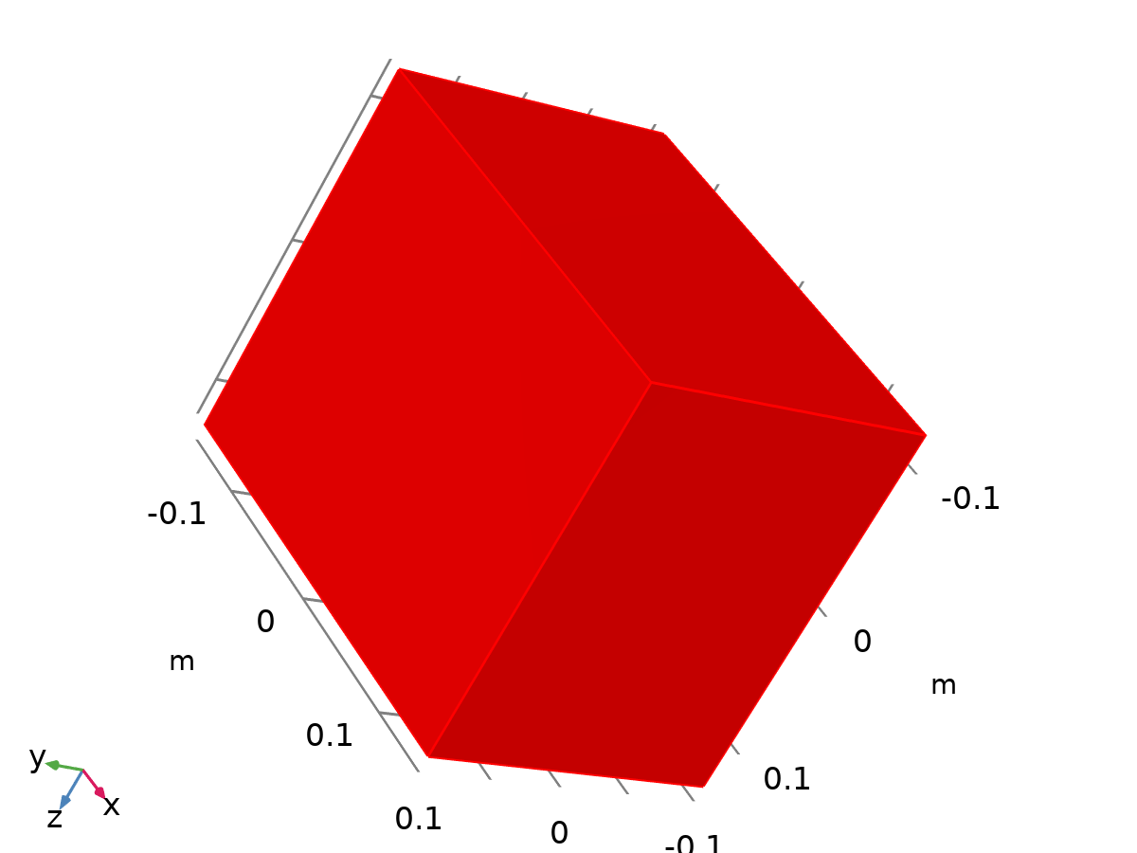

Dataset: Study 1/Solution 1